How to Amend Authentication Phone Number
On first logging into your MoJ laptop users were required to enter a mobile phone number in order to authenticate secure access to ICT systems.
If you plan to change the nominated mobile phone number (E.g. hand a work-issued phone back, purchase a new contract etc.) you will need to update the Multi-Factor Authentication (MFA) system with a new number.
- On your Intranet homepage, in the top-right hand side, click on your photo, or initials
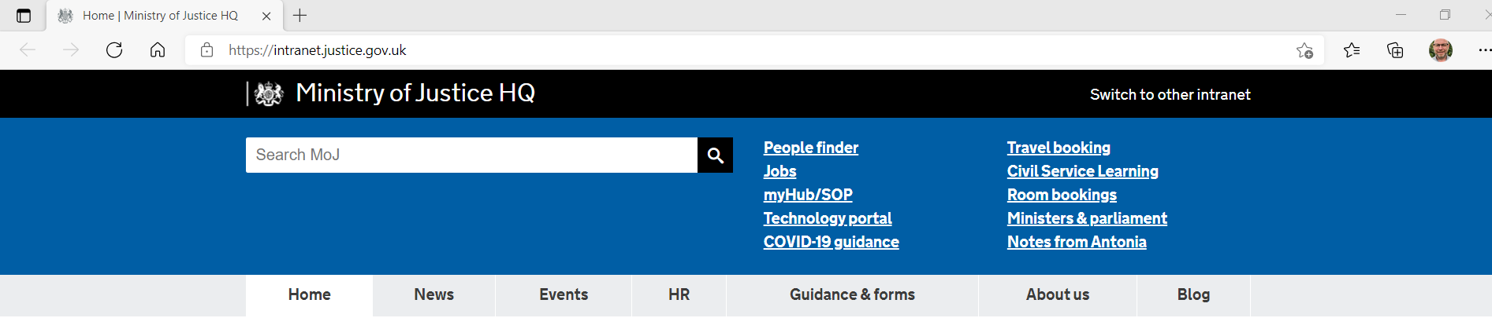

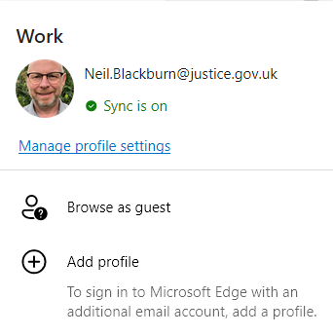
NB

- Click on ‘Manage profile settings’

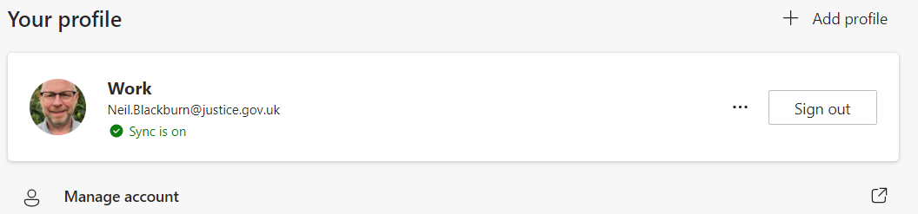
- Click on ‘Manage account’
NB

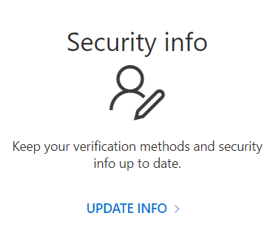

- Click on ‘UPDATE INFO >’

- Click on ‘Change’
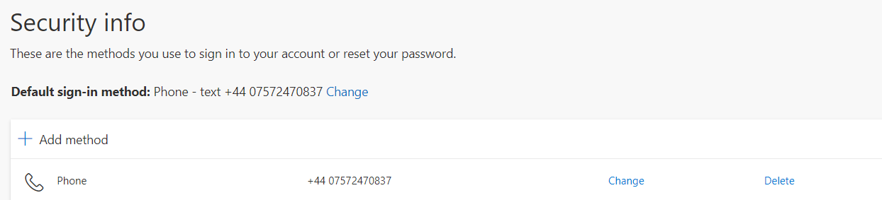
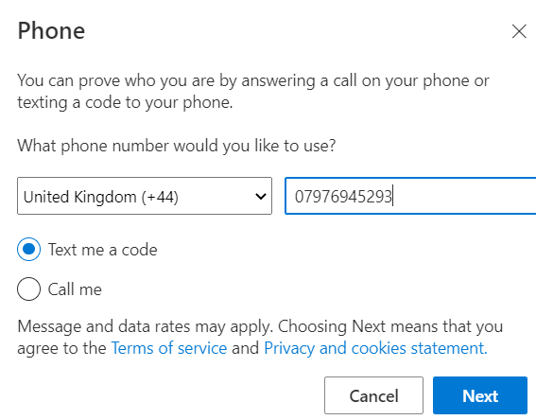

- Overtype your old number with the new number and select ‘Text me a code’ and click on Next

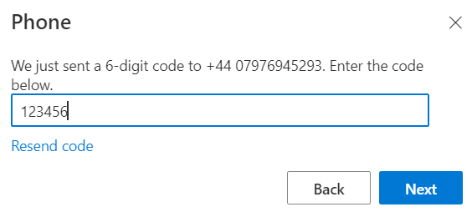
- Enter the code from the text you receive and click on Next

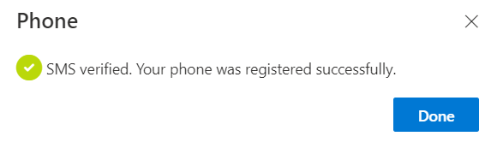
- Your phone number is now updated.

