Case Management Support

Practitioner Guidance

Version 11 - 1st July 2022
Contents
Introduction 3
Case management support (CMS) 5
List of Mandatory Activities and Suitability for CMS use 5
CMS in practice 8
Activities covered by CMS 8
Identifying Specific Tasks for the CMS Support Role 8
Recording CMS Activity 9
Recording on nDelius 10
CMS Contact Types and Timings 11
Trainee Probation Officers (PQiPs) 13
Regional audit activity requirements 14
Implementation & Training 15
Appendix 1 Case Management Support Agreement Template 16
Appendix 2 Reviewing CMS within the WMT 18

Introduction

- This guidance comes into effect overnight on 1st July 2022 following changes to Case Management Support and functioning within WMT. It is vital that all operational staff (SPO, PO, PSO and PQiP), and those who may be asked to support nDelius entries for operational staff are aware of these changes and aware of how to correctly apply and record CMS. This is vital to ensure continued accuracy of WMT and to ensure defensible oversight for the monitoring and management of risk and recording of activity

- Case Management Support was introduced in the NPS Sentence Management Model, as well as being part of the model for deployment of Probation Service Officer resource within the E3 staffing resource model. As the staff modelling and assumptions which underpin deployment of Probation Officer and Probation Service Officer resources have changed, the position of Case Management Support within Probation Service strategy and delivery needs to change to reflect post-unification needs

- Following reunification of Probation in July 2021, the above models represent ‘legacy’ ways of working/staff models, replaced by the Target Operating Model (TOM). The Target Operating Model continues to draw upon desistence approaches, which argues that ‘change’ is best facilitated through the quality of the relationship between a Probation Practitioner and the Person on Probation. The core foundations of a strong Probation Service have been distilled to simpler descriptions of Assess, Protect and Change

- During a review of Case Management Support, changes were identified to improve how CMS functions in practice; reliability of CMS use within WMT is addressed; and ensuring that CMS continues to offer managers and practitioners the ability to manage demand at high workload levels by distributing workload. The following changes were identified as key objectives

    - Improved accuracy and validity of CMS use within WMT – reducing workload distortions which occur
    - Ensuring guidance provides clear expectations on use and application of CMS
    - Regional audit activity is identified to assure correct use

- In the TOM each Person on Probation will have an identified Probation Practitioner (Responsible Officer in legislation) who is ultimately responsible for the delivery of the risk assessment, risk management and sentence plans through an individualised casework approach

- The provision of Case Management Support allows support for the Probation Practitioner when additional workload demand management is required i.e. not as a BAU process/tool. Full details are not provided here, but the Prioritising Probation Framework aims to provide clarity of focus of Sentence Management activity to essential tasks, supporting regional discretion to decrease priority of other areas of work when trigger points are reached

- Trigger points are reached when the gap of available staff against target staffing and/or when WMT workload reaches specific levels (shown below). Trigger points and associated RAG of Green, Amber and Red support the use of Case Management Support. During BAU levels, Case Management Support should not be applied.

Measure | Condition | RAG
WMT - Regional | WMT Under 110% for 4 weeks  WMT Over 110% and Under 120% for 4 weeks  WMT Over 120% for 4 weeks | BAU  Green  Amber
WMT - PDU | WMT Under 110% for 4 weeks  WMT Over 110% and Under 120% for 4 weeks  WMT Over 120% for 4 weeks | BAU  Green  Amber
Target vs SIP - Regional | Greater than 80%  Greater than 70% less than 80%  Greater than 60% less than 70%  Less than 60% | BAU  Green  Amber  Red
Target vs SIP - PDU | Greater than 80%  Greater than 70% less than 80%  Greater than 60% less than 70%  Less than 60% | BAU  Green  Amber  Red

- At the time of this review, the challenges and risks posed to operational delivery of sentence management activity are clear and influenced primarily (but not exclusively) by the shortages of Band 4 qualified Probation Officers. This scenario is true for many regions across the country. As the gap of staff in post and target staffing reduces and this situation improves the Case Management Support will be phased out, replaced by and BAU management activity

- Within this context, the review of Case Management Support has continued to identify that there is a need for a tool which will support managers and practitioners in workload and demand management decisions. The Workload Measurement Tool is one of the tools used to support this, by providing an overview of staff capacity and workload, as well as what type of caseload (licence/community/custody etc.) this workload comprises

- Case Management Support is being repositioned as a tool to further support workload management and aligned with the TOM. It will achieve this by allowing other staff to support delivery of core mandatory sentence management activity for another practitioner with clearly defined activity aligned with Assess, Protect and Change

Case management support (CMS)
- In addition to taking responsibility for the direct Sentence Management of their caseload, PSOs are able to undertake tasks which support cases held by POs, including delivering specific pieces of work identified in the sentence plan and non-offender facing activities such as more complex referrals, information gathering and liaison with other agencies. It is anticipated that the case management support role of the PSO will vary in intensity on a case by case basis in accordance with the risk factors and needs that each case presents
- As CMS is being repositioned as a focused tool to support workload demand management, it must reflect the current needs of operational delivery. Changes therefore include:

- Mandatory activities (core Sentence Management function work). Mandatory activities are those outlined in legislation and/or policy guidance. As indicated above, types of mandatory activity which include assessment of risk are not suitable for use in CMS. However, activity can be completed to support these activities e.g. intelligence gathering. Change activity is the most suitable area for CMS delivery, and this is consistent with the intention to implement POD structures within teams in the future

- The time associated with activities has also been updated and simplified to remove the low/med and high intensity. Instead, an aggregated measure of time has been applied. These were formed through practitioner engagement groups and underpin wider changes to the WMT. CMS and WMT must include the same basic assumptions of activity and time to ensure consistency

- The transfer of workload points within CMS has been reduced from 30 days to 7 days. This will continue to support the completion of specific activity and recognition within WMT, however will mitigate and reduce the distorting effect of this points transfer

List of Mandatory Activities and Suitability for CMS use
Assess | CMS Y/N | CMS category
ARMS element of initial / review assessment completed | N
complete home visit risk assessment | N
complete PAROM 1 | N
complete PAROM addendum | N
complete UPW assessment at induction* | Y | Assistance with Assessments
Diversity & inclusion (DIF) information recorded (induction / review) | Y | Assistance with Assessments
Initial assessment and sentence plan completed | N
Maturity assessment request and discussion with POM | N
prepare for and attend Oral Hearing | N
prepare, reflect and record handover | N
prepare, reflect, record 3-way meeting | N
prepare, reflect, record HV | N | Home & Prison Visits
pre-release assessment and sentence plan completed | N
pre-release handover meeting with POM, COM and PoP | N
review of assessment and sentence plan completed | N
SARA element of initial / review assessment completed | N
social worker liaison for care leavers | Y | Case Related Communication
termination of assessment and sentence plan | N
transfer case out of area | N
Travel to AP | N
Travel to HV | N
travel to prison for meeting | N
travel to prison for oral hearing | N
travel to prison for PAROM | N
undertake ARMS informed home visit | N
undertake home visit | Y | Home & Prison Visits
Update risk registers in nDelius (induction / review) | N
Protect | CMS Y/N | CMS category
attend child safeguarding case conference | N
attend child safeguarding core group | Y | Assistance with Case Conferencing
attend child safeguarding strategy meeting | N
Attend MAPPA panel | N
complete adult safeguarding referral | N
complete AP 3-way meeting with keyworker and PoP | N
complete AP move on plan* | Y | Assistance with Assessments
complete Approved Premises referral* | Y | Completing & Assisting with Referrals
complete breach pack* | Y | Assistance with Assessments
complete child safeguarding referral | N
complete IOM referral | N
complete MAPPA A form for L2/3 | N
complete MAPPA Q screening form | Y | Completing & Assisting with Referrals
complete MARAC referral | N
complete Partner Link Worker referral | Y | Completing & Assisting with Referrals
drug testing | Y | Sentence Plan Intervention Delivery
Issue 2nd compliance letter | Y | Case Related Communication
Issue first compliance letter | Y | Case Related Communication
Liaison with EM provider | Y | Case Related Communication
Notify electronic monitoring provider of breach | Y | Case Related Communication
ongoing liaison with VLO | Y | Victims Services Liaison
partner link worker liaision during programme | Y | Case Related Communication
police intelligence check | Y | Information & Intelligence Gathering
social services general safeguarding check | Y | Information & Intelligence Gathering
undertake referral to victim liaison team | Y | Completing & Assisting with Referrals
Licence specific | CMS Y/N | CMS category
Application to suspend supervision of lifer/IPP | N
complete HDC form* | Y | HDC assessments and support
complete licence variation request* | Y | Assistance with Assessments
complete ROTL form* | Y | HDC assessments and support
Fixed term recall Part A completion | N
Recall (Part A/B/C) | N
Standard recall Part A completion | N
Standard recall Part B completion | N
Standard recall Part C - review re-release | N
Change | CMS Y/N | CMS category
complete induction | Y | Sentence Plan Intervention Delivery
prepare, reflect, record induction | N | Sentence Plan Intervention Delivery
complete pre programme work for BBR | Y | Sentence Plan Intervention Delivery
mandatory monthly supervision | Y | Sentence Plan Intervention Delivery
prepare, reflect, record mandatory supervision | N | Sentence Plan Intervention Delivery
RAR 1-1 toolkit session | Y | Sentence Plan Intervention Delivery
complete session to prepare for intervention - AP / SI / CRS | Y | Sentence Plan Intervention Delivery
supervision sessions above mandatory monthly contact | Y | Sentence Plan Intervention Delivery
IOM supervision session | Y | Sentence Plan Intervention Delivery
complete referral to CRS provider | Y | Completing & Assisting with Referrals
complete referral to SI provider | Y | Completing & Assisting with Referrals
complete referral to accredited programme | Y | Completing & Assisting with Referrals
complete housing referral under duty to refer | Y | Completing & Assisting with Referrals

CMS in practice

Activities covered by CMS
- The table on pages 5-7 provides the list of mandatory activities which can be covered by CMS, and those which cannot be included directly – but may be supported by associated tasks

- If an activity is not listed above, it may be considered a ‘responsive task’ i.e. a task which may be required for completion but is not mandatory (outlined in legislation and/or policy guidance). Responsive tasks cannot be included within CMS. This is to ensure that the revised CMS tool is used to support workload management decisions of core and essential Sentence Management tasks only

Identifying Specific Tasks for the CMS Support Role
- The table on pages 5-7 outlines the main tasks that a practitioner may be asked to undertake in the OM support role. The following key principles must apply to any task given to a PSO:
  - It should be within their competence (as outlined in the PSO training framework)
  - The tasks should not include those of direct responsibility of the Probation Practitioner (e.g. completion of risk assessments), but may support this activity e.g. information gathering/agency liaison
  - It should link directly to the delivery of the sentence plan in some way
  - Tasks should be time bounded and specific
  - The Probation Practitioner will need to retain oversight of the task completion to ensure that the Probation Practitioner remains able to monitor and manage risks
  - Probation Practitioners should not use CMS for cases they are allocated
- Therefore, whilst it would be inappropriate for a PSO Probation Practitioner from being the Probation Practitioner for a high risk of serious harm case it would be entirely appropriate for a PSO to provide Sentence Management support to a high risk of serious harm Person on Probation, and this may provide useful learning and development opportunities for staff

- Assessment and judgement will play a key role here as to suitability of the nature of the activity, but also the Person on Probation and their needs/contexts

- To help provide clarity an agreement between the Probation Practitioner and the PSO providing OM support can be helpful. Appendix 1 provides an example of such an agreement. This is not mandatory but may be helpful in some cases

Recording CMS Activity
- A recent review of CMS has outlined examples of inappropriate use and recording of CMS. This include:
  - Blank CMS entries – this should never occur. If a CMS entry has been added as an additional/duplicate entry in relation to another entry (e.g. a statutory appointment home visit), the details of the activity for this contact should be copied across
  - Repeated use of CMS entries for the same Person on Probation on the same day (e.g. multiple Case Related Communication activities) should not occur. The categories of CMS type include a broad range of activities and in some instances, there may be overlap. Additionally, the activities are not intended to represent individual pieces of work e.g. Case Related Communication may relate to multiple actions within this, not a single phone call/meeting. In addition, if activity is likely to take less than 15 minutes to complete, CMS should not be used. This includes activities such as
      - very short phone calls where the Person on Probation has not answered the phone
      - when an e-mail has been sent on behalf of the Probation Practitioner
      - A phone call, email etc, should not be recorded as CMS, it is just part of the work we do to support another PP
      - Entries such as “left voicemail” or “reminded to attend for appointment” etc which are recorded as CMS should be stopped and only record the work which has a significant outcome

  - Use of CMS for long-term sickness should not occur. In instances where a colleague is absent from work on long-term sickness, managers should reallocate caseloads and not use CMS
  - CMS should not be used for unallocated cases. The exception is use of CMS for completion of ROTL activity for cases which cannot be allocated as they fall under Prison Offender Manager responsibility. Outside of this example, CMS should never be used on unallocated cases. CMS reallocates points from one practitioner to another. If there is no practitioner to ‘borrow’ from this creates a distortion effect on the measure of workload
  - CMS should never be used when a Probation Practitioner attends/visits a contact with the allocated Practitioner (Responsible Officer). This applies to joint home visits/prison visits and/or three-way meetings where a Practitioner observes practice to support learning and development and/or mentoring opportunities
  - CMS entries for PoP contact are not recognised by performance/quality reports as standard. This means that a Practitioner may need to enter the contact (e.g. Statutory Home Visit) on nDelius as standard, and then enter a CMS contact. It is vital that details/notes of the contact are copied into the details/notes for the CMS contact.

Recording on nDelius
- Currently, all the points for managing a case are allocated to the Probation Practitioner named as the “Community manager" on nDelius

- The WMT will automatically transfer the workload points between the Probation Practitioner (named Community manager) and the “CMS PSO support officer” who completes and records the agreed Case Management Support activity in nDelius. The workload points corresponding to the recorded task will be deducted from the Probation Practitioner and assigned to the CMS PSO. There will be no requirement for SPOs to record adjustments to Reduced Hours in WMT. The CMS PSO support officer should not be recorded as an Order or Requirement Manager on nDelius

- There are two parts to recording Case Management Support activity in nDelius and these are described and shown in the screen shots

- Create a new contact and chose the relevant event which this relates to
- In ‘Contact Category’, select Case Management Support from the drop down list
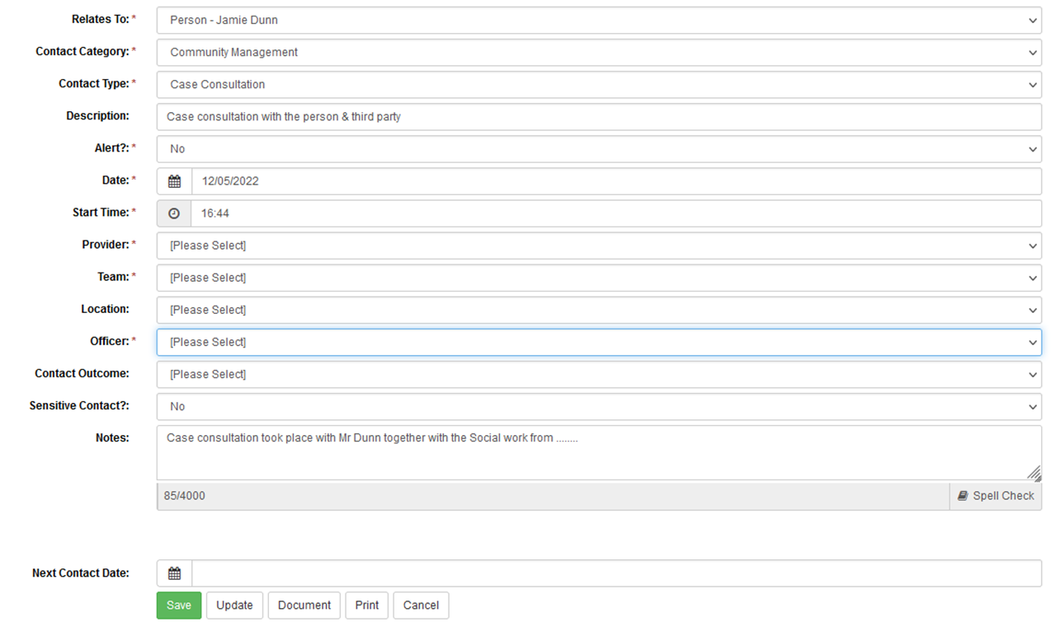

- In ‘Contact Type’, select the category of CMS which refers to the activity completed
- All other fields should be completed as expected
- Please note that the ‘Notes’ box should never be left blank. A CMS contact may be entered as a duplicate of another entry (e.g. Prison Visit, or Planned Office Visit) – if this is the case, then the notes from this entry should be copied into the CMS contact

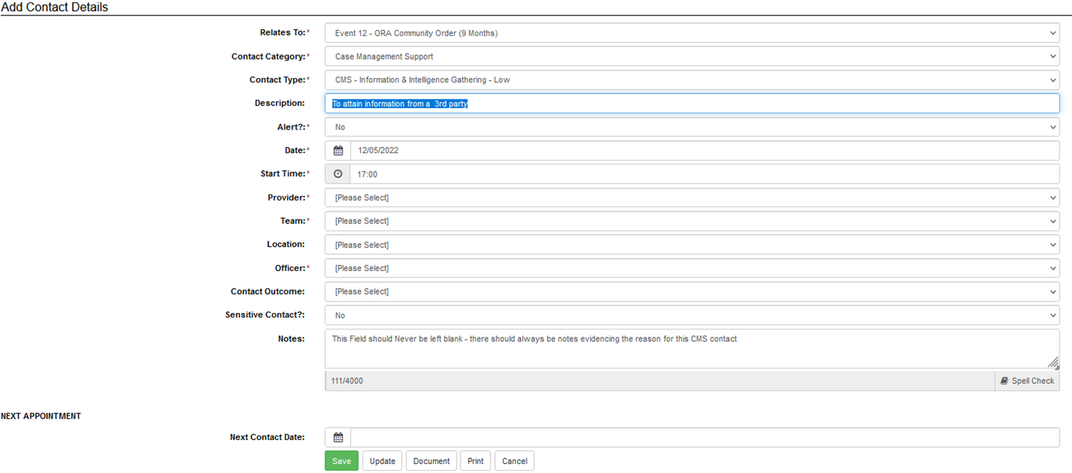

CMS Contact Types and Timings
- There are 12 new generic Case Management Support contacts broadly covering the CMS activities outlined above on page 5. To simplify CMS application, and to reduce the variability in use, the previous low/medium and high intensity sub-categories have been removed and replaced with a single CMS type for each category

- Timings have been agreed with practitioners as part of a wider review of Probation Service activity and processes which underpin wider WMT changes. These timings are an average position and it is understood that some CMS tasks may take longer than the stated allowance, however over time this will be offset by instances when the CMS activity has taken less time than expected

- The person recording Case Management Support activity should select the contact that best describes the activity delivered

- The above guidance on recording of Case Management Support in nDelius comes into effect overnight on 1st July (staff will see the changes on 4th July). The timings/weightings will automatically export to the Case Management Support Officer in WMT for a maximum of 7 days after the contact has been completed

- When making these entries, the PSO, (or their Case Administrator as may be the case) should ensure the PSO’s name is in the Officer field to ensure the workload points are credited to them. They should also use the Notes field of the secondary contact to indicate what primary contact it relates to as per the picture below. The notes field should never be left blank.

Table showing CMS contact types and timings compared to legacy CMS timings
 | Current CMS timings
Row Labels | Low complexity | Medium complexity | High complexity | Revised CMS
Assistance with Assessments | 30 | 45 | 60 | 30
Assistance with Case Conferencing | 30 | 60 | 90 | 60
Case Related Communication | 15 | 30 | 60 | 20
Completing & Assisting with Referrals | 30 | 60 | 90 | 30
Home & Prison Visits | 30 | 45 | 60 | 60
Information & Intelligence Gathering | 30 | 45 | 60 | 15
Sentence Plan Intervention Delivery | 30 | 45 | 60 | *60
Victims Services Liaison | 15 | 30 | 45 | 15
HDC assessments and support | 30 | 45 | 60 | 45
ROTL assessments and support | 30 | 45 | 60 | 45
Attending partnership meetings | 30 | 60 | 90 | **60
Court liaison and applications to Court | 30 | 45 | 60 | 45
*includes preparation and write up time
** timings are taken as an average of lower and higher complexity CMS activities

Trainee Probation Officers (PQiPs)
- PQiPs are employed on a joint-role basis and are both learners and also part of the PSO establishment. As such, PQiPs (subject to learning route and stage of completion) hold their own caseload. As part of this PSO role, PQiPs can and should complete CMS activities as part of the PSO element of their role.
- Additional input and judgement from the practice tutor assessor [PTA] and the SPO may be required to determine what activities and cases would be suitable for a trainee at each stage of their development based on the training they have received and their confidence and ability.
- PQiP learners should no longer use Case Management Support to record any activity related to cases they are co-working as part of the learning and development. Protected learning time reductions provide allowance for this activity, and visibility of workload and capacity within WMT.

Regional audit activity requirements
- Regional audit and quality assurance activity will be required (e.g. DIP samples) to ensure that CMS is being used correctly and effectively following the changes. This should include as a minimum
  - Ensuring that CMS Notes entries are not blank and that the entry provides sufficient information on the nature of the contact and what activity was undertaken
  - Ensuring that correct CMS contact types are used
  - Ensuring that multiple CMS entries are not used for the same Person on Probation on the same day
  - PQiP learners are not recording for co-working of cases
  - CMS is not used for unallocated cases (aside from unallocated ROTL requests)
- As the retention period of CMS is moving from 30 days to 7 days (calendar days), regional P&Q teams will be required to run CMS report extracts from WMT on a weekly basis, although this does not necessitate weekly audit/quality assurance activity which can be sequenced into BAU P&Q activity

Implementation & Training
- To ensure continuation of CMS during the change-over from legacy CMS to revised CMS, the legacy CMS points will be transferred to the new CMS contact types, timings and points. For some staff this may mean a small fluctuation in WMT points from the date of the change, but this is expected to be small for the majority of practitioners

- We are aware that legacy CRC colleagues may be less familiar with use of CMS than legacy NPS colleagues. With this in mind, we have created a series of bite-size videos covering the below topics
    - Basics of WMT
    - How to access WMT, how to find your team
    - Information that WMT provides a manager/practitioner
    - Accessing, checking and updating reductions
    - Applying CMS

- It is anticipated that the majority (but not totality) of CMS activity will be undertaken by PSOs (including PSO component of PQiP learners) for PO colleagues. It is for PP SPOs, supported by their divisional training teams to identify the Sentence Management activity training needs of staff in their team, and this will need to be considered when assessing suitability of application of CMS. The training and competence framework for PSOs can be found on EQUIP

- PP SPOs are reminded that PSOs should not be allocated tasks where they have not completed the training and demonstrated competence. Some consideration will need to be given to ensuring that tasks allocated to PSOs in the OM support role are completed to the required standard. This could include direct observation as well as feedback from the PP responsible officer.

Appendix 1 Case Management Support Agreement Template

Case Management Support Agreement

The following agreement outlines the specific case management support tasks that will be undertaken with the identified service user.
Probation Practitioners are reminded that as the responsible officer they are ultimately responsible and accountable for the delivery of the risk management and sentence plans through an individualised casework approach. Where PSOs are undertaking specific Sentence Management support tasks the following must be taken into consideration.
- It should be within their competence [as outlined in the PSO training framework]
- It should link directly to the offender’s sentence plan in some way
- Its should be time bounded, i.e. the PO Probation Practitioner cannot ask the PSO providing case management support to “deliver the sentence plan”.

AGREEMENT
Service User Name:
CRN:
Probation Practitioner:
PSO providing CMS:
Specific CMS Task[s] to be undertaken: |  |  | Time Frame for Completion
1)
2)
3)
4)
5)
Activity Timing: Low, Medium or High?
SPO Agreement:
Dated:

Form continued on next page
Copies of the signed agreement must be retained on the electronic case file.
Guidance on Case Management Support Agreements
PSOs should not be allocated cases assessed as Tier A or B, and Tier C2/3 depending on their experience and training. Therefore, line managers should ensure that such cases are allocated to a sufficiently qualified/experienced and trained practitioner, with the PSO undertaking agreed tasks and activities.
In the absence of the named Probation Practitioner, the PSO will seek advice and support from their line manager or a colleague PO.
The PSO will be responsible for maintaining records as required by relevant policies and standards including recording on nDelius any work conducted on behalf of the PO.
The Probation Practitioner is responsible for making sure they are regularly updated [ideally through conversation as opposed to email] on the work being delivered by the PSO and noting this on nDelius to ensure they retain oversight and are informed to monitor and manage risks appropriately.
This form should be discussed and completed by the Probation Practitioner and the allocated PSO for each case designated for co-working and endorsed by the line manager.

Appendix 2 Reviewing CMS within the WMT
For CMS allowance to be updated to the WMT – you should record the activity on nDelius as shown on pages 8 and 9 of this document.

Each individual CMS activity will remain constant within the WMT for a period of 7 calendar days, after this period has expired, it will automatically be removed from the WMT. If work continues as a Case Management Support activity, you should update the nDelius contact with a new current activity to attain the relevant weighting.

To review Case Management Support within the WMT:
Click on the Capacity tab – this will show CMS overall for a Division/LDU or Team – it cannot be viewed at individual OM level. The following example is for a team: CMS column is located on the right-hand side. The PO’s/PSO’s who show below with a minus reduction – are those PP’s who have staff supporting them via CMS – i.e. PSO1 is receiving 34.10% in the CMS column, as they have recorded the CMS contact activities they are undertaking for other staff within their team.

In effect the person who is named as the CMS member of staff within the nDelius contact will receive the %, and the same % will be removed from the named Probation Practitioner:

Probation Practitioner |  | Workload breakdown
Name | Grade | Capacity (%) | Cases | T2A | ARMS | PAROMs | FDRs | SDRs | GS | CMS
PO1 | PO | 117.20% | 44 | 0 | 0 | 0 | 0 | 0 | 0% | -0.60%
PO2 | PO | 106.20% | 39 | 0 | 0 | 0 | 0 | 0 | 0% | -5.80%
PO3 | PO | 115.50% | 36 | 0 | 0 | 0 | 0 | 0 | 0% | -6%
PO4 | PO | 107.30% | 46 | 0 | 0 | 0 | 0 | 0 | 0% | -1.90%
PSO1 | PSO | 44.50% | 29 | 0 | 0 | 0 | 0 | 0 | 0% | 34.10%
PSO2 | PSO | 58.60% | 35 | 0 | 0 | 0 | 0 | 0 | 0% | 2.40%
PO5 | PO | 105.10% | 45 | 0 | 0 | 0 | 0 | 0 | 0% | -0.70%
PSO3 | PSO | 59.60% | 28 | 0 | 0 | 0 | 0 | 0 | 0% | 6.90%

Case management Support does not differentiate between staff grades. In some teams – 2 PO’s may be managing a case, only one PO (who is the named PP for the nDelius record) can attain the weighting for the Sentence Management work. The 2nd PO would in effect receive No weighting. To counterbalance this the 2nd PO can receive some weighting by completing the Contact for Case Management Support activities in nDelius.

This would mean the Named OM would receive the overall weighting for the relevant tier of the offender, but would also show with a minus percentage in the CMS column – as the Supporting (2nd) PO would be receiving the weighting for the Case Management Support element.

The above would equally be the same for a PO and PSO:- The PO would receive the overall weighting for the offender – but would show a minus for CMS – IF a PSO is completing some Case Management Support for the offender. The PSO would receive the weighting associated with the relevant nDelius contact for Case Management Support they have completed.
Please remember in some teams – PSO’s complete Case Management for PO’s outside of their own teams – so may have a higher percentage than those shown PO’s for a minus reduction.

