



**Community Payback Placement Coordinator Induction Manual**

V2 29/06/2022



‘Firstly, congratulations on choosing one of the most rewarding jobs, not just within the justice system but the wider public sector. Working as part of Community Payback allows you to not only effect positive change but see the tangible outcome with those we supervise. Community Payback is the most visual element of Probation, it offers both a punitive requirement that helps people on probation to make reparation to the community but this element is also inseparable from its rehabilitative potential, providing basic employment skills and instilling the importance of teamwork.

The impact that Community Payback is having not just on people on probation but society and the environment truly highlights the power of Probation. This means that through supporting environmental initiatives you will also be supporting people on probation to make a lasting difference to their local area and enhancing their connection to the community, decreasing the chances of them reoffending. The general public, public bodies and officials show a real gratitude for the work we do within their community, whether that be reviving green spaces or bringing a sense of safety to a rundown space, know that you are making a real difference on a daily basis.

I’m excited that you are joining us as a Community Payback Placement Coordinator at a really exciting time for the Probation Service and the Community Payback team. I wish you the best of luck in your role and warmly welcome you to the Probation Service.’

Amy Rees,

Director General of Probation, Wales and Youth

**Introduction**

Many Congratulations on your appointment as a Community Payback (CP) Placement Coordinator. You are undertaking a really interesting, important, varied and sometimes challenging role that if carried out well makes an enormous positive impact on individuals as well as local communities.

**Claire Farquhar Head of Interventions for Community Payback in London comments**: *‘Identifying and setting up quality projects that provide not only visible justice but the opportunity for a Person on Probation (PoP) to develop transferable skills is critical to delivery of a quality service and our capacity to deliver the sentence of the Court. Your role in forming positive relationships with beneficiaries, People on Probation and colleagues is fundamental to the success of projects, the reputation of Community Payback and the impact on the community’*

This Induction is designed to supplement the two corporate inductions you will have received on joining both the Probation and wider Civil Service. It is designed to provide you with a more specific overview of your role as a Community Payback Placement Coordinator.

* It will provide you with an Introduction to Community Payback and how your role fits with the wider aims of the scheme.
* Then, with the contributions of some Supervisor colleagues, will cover the key aspects of the effective delivery of a Community Payback project.
* Also, some of the key responsibilities of a CP Supervisor who you will be working closely with in your role and on occasions will need to cover.
* Finally, the Manual with outline some of the key elements of the Placement Coordinator role, once again with contributions from colleagues currently carrying out the role.

The Induction will provide you with a brief overview of the requirements and expectations of the key aspects of your role, where you can access more detailed information and reading, the training you will provided with to support you and tips and advice from experienced, competent colleagues who are passionate about the role.



**Introducing Community Payback Supervisors:**

To help guide you through some of your key responsibilities outlined in this Induction are two colleagues currently working as Community Payback Supervisors, Phil Crocker from the London Region and Colette Chambers from the East of England.

We started by asking them about some of their experiences in the role:

**Q1: How long have you worked in Probation and as a Supervisor?**

**Collette:** *‘I have worked in Probation for nearly 30 years and done lots of different roles from being a Court Officer, a Probation Service Officer (PSO) managing cases, worked in Approved Premises (AP) before working in my current role as a Supervisor’.*

**Phil**: *‘I used to work as a Prison Officer I started working as Community Payback Supervisor on a sessional basis before becoming permanent member of staff in May 2020’*

**Q2: What is the best and most rewarding aspect of the job?**

**Collette:** *‘You get to meet and work with a huge range of people; it is a complete cross section of society from prolific offenders to professional people finding themselves on a Community Order for the first time. One of the most rewarding aspects is seeing people change from often being resistant to carrying out the work, to actively engaging and learning new skills. When People on Probation receive praise from beneficiaries or members of the public it can help them to feel more part of society again.’*

**Phil:** *‘I consider myself to be a people person. While attending it is important that people complete and are seen to complete their punishment. The role also provides me with the opportunity to get to know individuals and challenge some of their perspectives and attitudes that might have contributed to their offending’*

**Q3: What is the most challenging aspect of the role?**

**Collette**: *‘Many of the people who are required to carry out Community Payback have often not had the most positive experience of authority. Therefore, sometimes it can be challenging to break down barriers to engage effectively and ensure the required standard of work is carried out. But this is something you get better at overcoming over time and with experience and developing your engagement skills. It can also be the most rewarding aspect having a young person who was initially resistant getting up on time to get to the project, learning new skills and seeing the rewards of their efforts’*

**Phil:** *‘Because people are completing their hours, or some being returned to court for non-compliance, the dynamics of the group often change with new people coming in. It is important to be conscious of this in order to manage if effectively.’*

**Q4: What advice would you give to someone just starting the role?**

**Collette: *‘****I feel it is important to be non-judgmental. You cannot take a one size fits all approach as every individual who attends Community Payback is different. You need to develop a style where you are able to maintain authority by building effective working relationships and being able to roll with pockets of resistance’*

**Phil: *‘****Make the most of the shadowing sessions you are offered at the start to learn from experienced colleagues. While you are often working alone it is important to remember that colleagues are always on the end of the phone if you are coming across new or challenging situations.’*

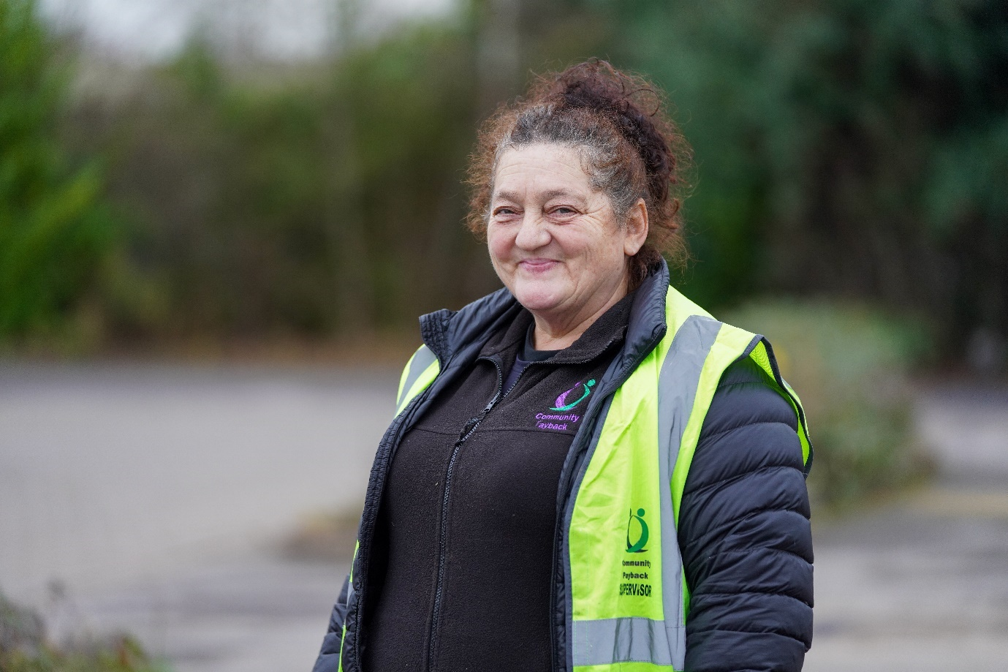

**Section 1: An Introduction to Community Payback**

**A History of Community Payback**

Unpaid Work (UPW) as a sentence of the Courts started in 1973 as ‘The Community Service Order’. The Criminal Justice and Court Services Act 2000 renamed the Community Service Order as a Community Punishment Order. The Criminal Justice Act 2003 created the Community Order, a sentence that can be made up of one or more requirements; Unpaid Work is one of these requirements. The same requirements apply to the Suspended Sentence Order. Courts can impose sentences of between 40-300 hours, reflecting the seriousness of the offending.

Community Payback is the term used to refer to any work done as part of an Unpaid Work Requirement within a Community Order (CO) or Suspended Sentence Order (SSO). It also refers to the organisational structures required to deliver Unpaid Work in the community. The sentence of the court remains an Unpaid Work Requirement (imposed as part of a court order) which is set by legislation. Community Payback was launched in 2005 to promote public awareness and understanding of the Unpaid Work Requirement. This was done by focusing on greater visibility, raising public understanding of the sentence and giving the public a chance to nominate work projects.

During the national lockdowns that occurred as a result of the Covid-19 pandemic Community Payback was unable to be delivered nationally. Since returning up until recently projects had been only able to run at limited capacity with often less than half the number of Persons on Probation that would have previously been attending. This has meant that a significant backlog of cases has built up. In order to clear this backlog by 2025 nationally the Probation Service will need to significantly increase our delivery. In order to achieve this, we need to recruit and train a number of new colleagues, so you are joining us at the perfect time.

**Key Principles of delivering an Unpaid Work Requirement:**

All Unpaid Work Requirements must be completed within 12 months of sentence, irrespective of the length of the Community Order or Suspended Sentence Order. All cases that have an Unpaid Work Requirement are required to be reviewed at the 6-month point and 9-month point, and action taken if progress is not sufficient so if it looks like the PoP is unlikely to complete their hours within 12 months. If there are outstanding hours on the UPW Requirement after the 12 months, the obligation to complete the requirement continues, so if the PoP we are managing fails to complete their hours within this timeframe the backlog will continue to grow. The Unpaid Work Requirement must be returned to Court for an application to vary (either extension or revocation). In Suspended Sentence Cases, Probation Practitioners can apply for the Unpaid Work Requirement to be extended but only to the end of the Operational Period.

**Person on Probation journey through an Unpaid Work Requirement**

The graphic below outlines a Person on Probation’s journey through an UPW Requirement from induction following sentencing at court through to completion of their hours or being returned to court as a result of enforcement action.

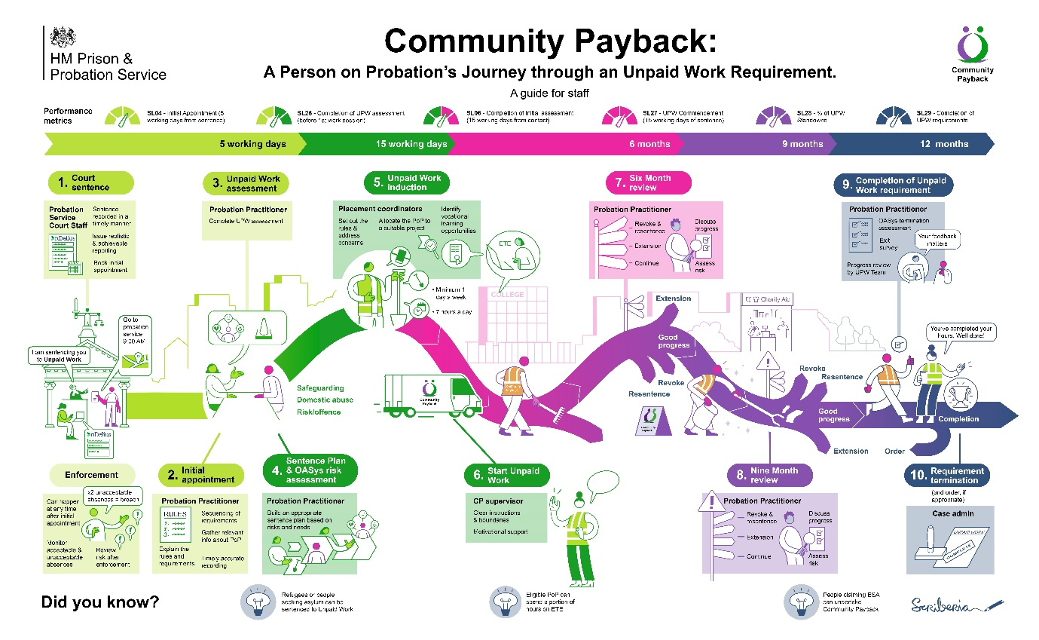

**Induction:** Following sentence a PoP should receive their first appointment within 5 working days. This is where the rules of both the Community Order and the Community Payback projects are explained to the person. A number of personal details will be checked and also information will be gathered around the person’s offending history to ensure the person’s risk of harm is assessed and that they are appropriately and safely placed on a project.

**Assessment/ Placement:** The Probation Practitioner (PP) is required to complete the Unpaid Work digital assessment tool with in fifteen working days to ensure a person on probation is placed on an appropriate project. The Probation Practitioner is also required to complete an E-Oasys assessment that includes a risk management plan as to how the PoP’s risk of harm to the public is going to be managed within 15 working days of sentence. This assessment will also include a sentence plan which is a plan that is signed by the PoP identifying how and in what order interventions on the sentence are going to be delivered.

**Project Delivery:** There are a number of ways in which a Person on Probation can complete the hours of their Unpaid Work Requirement:

**Group projects**: Offering the most effective way to deliver the Requirement at high volume, working as a group encourages a broad mix of individuals to work together towards a common goal; promoting teamwork and effective communication in a work environment. These are projects that you will be delivering in your role as a Community Payback Supervisor.

**Individual placements (IP)**: An effective way to enable an individual who is unable or unsuitable for group work to complete their hours in a more flexible manner. Placements typically include working in a charity shop with supervision being provided by the beneficiary

**PoP Identified Placements (PIP)**: Providing a wider range of opportunities, beyond current Individual Placements, that a PoP may have a personal link to or that has been identified as a placement that they have interest and access to. This many also allow Community Payback hours to be undertaken when a group placement is too restrictive, for example where a PoP has caring responsibilities.

**Education, Training and Employment (ETE)**: People on Probation can have a percentage of their Unpaid Work hours credited for undertaking interventions around education and employment. These interventions need to be agreed with the Probation Practitioner supervising their case and should aim to move them closer to employment, increase their employability if their employment is at risk or help them to progress in their current career.

**Enforcement:** If a Person on Probation fails to attend or comply with a Community Payback session or any other appointment they are required to attend as part of their Community or Suspended Sentence order; an enforcement letter will be sent by their Probation Practitioner advising them to provide evidence as to why the absence is acceptable with in five working days of the letter being issued. If the PoP fails to do so the absence is deemed unacceptable. If a Person on Probation has two unacceptable absences this will result in them being in breach of their Order. If they are found guilty this will result in a further criminal conviction and the court has a range of sanctions available including revoking their current order and resentencing the PoP. For this reason, it is very important that we clearly record when a Person on Probation has failed to attend, been late for a project or failed to comply with a reasonable instruction.

**Key Roles in Delivering Unpaid Work**

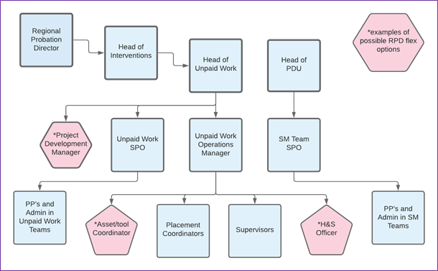

**Community Payback Supervisors:**

Supervisors primarily ensure People on Probation complete their Unpaid Work hours on group projects in the community. Core responsibilities include:

* Providing instruction and guidance to groups of People on Probation; ensuring their behaviour is managed appropriately and they are working safely.
* Driving Probation Service minibuses/vehicles to transport People on Probation and/or tools and equipment to projects.
* Ensuring the work on projects offers a credible punishment providing reparation to the community.
* Supporting People on Probation to gain employment skills through a positive work experience.
* Contributing towards a culture of continuous improvement within the Community Payback team.
* Demonstrating a commitment towards equality and inclusion, challenging discrimination, appropriately and professionally.

**Community Payback Placement Coordinators:**

Placement Coordinators are primarily responsible for establishing and maintaining relationships with a range of current and future partner organisations and stakeholders. Core responsibilities include:

* Ensuring sufficient availability of work placements which meet recognised quality standards, including contingencies for wet weather or unforeseen problems.
* Promoting Community Payback in their community, engaging with stakeholders to source and establishing new and innovative projects which offer learning opportunities for People on Probation.
* Conducting health and safety assessments of work projects/placements, ensuring compliance with organisational policy and health and safety legislation.
* Identifying opportunities for promoting environmental sustainability, reducing travel and reducing carbon emissions on projects minimising or offsetting the use of power tools.

**Community Payback Operations Managers:**

The Operations Manager provides leadership and management to the Community Payback Team. Their key responsibilities include:

* Ensuring projects/placements are well planned, sufficiently resourced and effectively managed to ensure they deliver high quality outcomes.
* Providing line management to a dispersed staff group and an on-call duty rota to ensure staff have access to management support.
* Using management information to monitor and drive improvements in team performance.
* Engaging with stakeholders, including: sentencers, the office of the PCC, local authority forums, community groups etc, to promote Community Payback, negotiate partnership agreements and support ongoing relationships.
* Overseeing health and safety practice, quality assurance and ensuring learning from accidents, incidents and near misses is shared.
* Promoting and demonstrating a commitment towards equality and inclusion.

**Probation Practitioners (Probation Officer/ Probation Service Officers/ Senior Probation Officers):**

Probation Practitioners, also known as Probation Officers (staff who hold a Probation qualification and manage high risk cases) and Probation Service Officers (who may have a different qualification and generally manage medium and low risk cases) are responsible for the assessment and management of the PoP cases.

* They will complete an initial risk assessment of the PoP to assess the risk of serious harm they pose, their risk of reoffending and complete a risk management and sentence plan. They will review this plan if there is any significant change in circumstance.
* They will also complete a digital Unpaid Work assessment tool that helps inform the safe placement of a PoP on to a project.
* They are responsible for liaising with other agencies to ensure that the PoP risk in the community is safely managed.
* They will ensure enforcement action is taken when the PoP fails to comply.
* Senior Probation Officers are responsible for line managing Probation

Practitioners and overseeing the quality of their work.

**Further Reading / Training**

For more detailed outlining of the structures that underpin Community Payback you can read the Community Payback Operations Manual and the Target Operating Model both documents can be found on EQUIP.

You can access all key policies and procedures for Unpaid Work by following the current link and entering your equip username and password:

[Unpaid Work (UPW) (rocstac.com)](https://equip-portal.rocstac.com/CtrlWebIsapi.dll?__id=webMyTopics.searchOne&k=2300&as_sfid=AAAAAAUiVf_0HkokHpFBe3nTUbuESB0Vn7VUPl6xfOdw-wEoNk1w6ZR5HBAclWk802pL2NyC7EMD18WKTviy4QIB-mNsDAnuTV_1G55Cudf1KtkHamgQH_GK9nzgvapigYjHq-o%3D&as_fid=cd52d453f1c4739f619c7071414074b2ca447b3f)

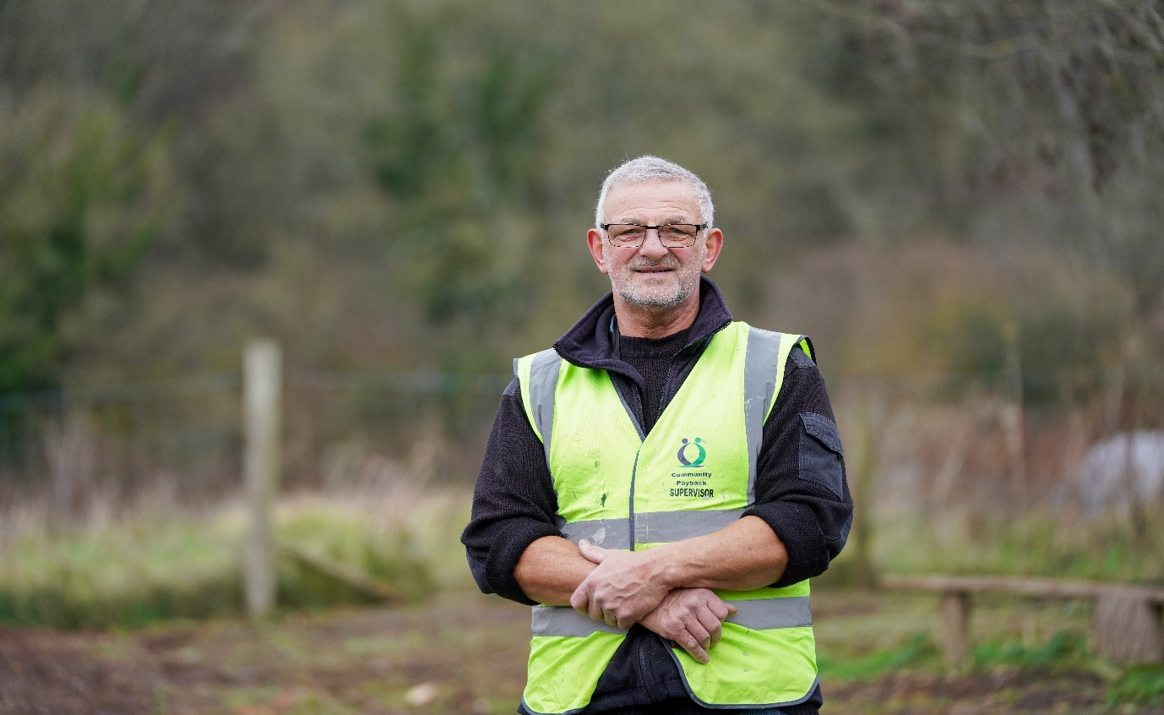

**Section 2. Engaging effectively with People on Probation,**

**beneficiaries and colleagues**

**Diversity**:

In delivering Community Payback it is important that we are conscious of diversity and adapt our practice to meet the needs of the diverse communities we serve. Attendance on Community Payback must not be prevented or restricted because of a protected characteristic that could lead to discrimination or behaviour that creates exclusion. The Community Payback Operations Manager has a specific remit to work with the regional equalities lead to champion diversity in the delivery of Community Payback. They will work with partner agencies to identify placements within specialist agencies or organisations that support the integration and inclusion of specific cohorts of people with protected characteristics. Some examples are provided below of common adjustments and considerations that Community Payback staff need to make, these examples are not a complete or exhaustive list of diversity considerations.

**Neurodiversity:**

Neurodivergent conditions include: Dyspraxia, Dyslexia, Attention Deficit Hyperactivity Disorder, Dyscalculia, Autistic Spectrum, Tourette Syndrome, and others. Key factors to consider include:

* Written information must be clear and concise, avoiding jargon.
* Supervisors need to be aware of an individual’s neurological condition in order to prepare an appropriate strategy for managing them on a placement.
* Supervisors need to have a good level of awareness of the issues associated with neurodiversity, provided through training and learning resources.
* Additional support available should be tailored to meet the individual needs e.g. giving clear instructions, explaining what the task is and why it’s important, explaining the structure of the day.

**Religion:**

Community Payback teams will recognise the need of all People on Probation to practice their faith. It is also reasonable for staff to expect some flexibility and for some prayers to take place outside of project/placement working hours. Religious belief, and any adjustments required, will be discussed with the individual prior to them commencing Community Payback, to allow for this to be communicated to the Supervisor.

**The Islamic faith**: It is obligatory for a practising Muslim to pray 5 times a day at specific times. During a full working day there could be the need for two prayer times. An extended break at lunch time and during the afternoon break may satisfactorily accommodate prayer time. When away from home practicing Muslims will complete the obligatory part of the reading, which will take about 10 minutes. It is important to accommodate these needs where possible. If in the judgement of the Person on Probation there are no suitable places to pray at the work placement, the missed prayers can be made up at the next prayer time. Prayer is not a legitimate reason to miss Community Payback or to leave the placement site, unsupervised.

**Language:**

There might well be occasions when Community Payback Supervisors are supervising a Person on Probation where English is not their first language. It is important that the Person on Probation’s needs (where possible) are accommodated whilst they attend for Community Payback. Ensuring that instructions on site are fully understood is also an important factor to running a safe working site.

All Supervisors will be issued with guidance detailing how to access interpreting services via phone which will help remove the barrier to effective communication in these situations. However due to the cost of this service it should only be used to communicate essential information, such as tool- box talk demonstrations, clarification of rules and regulations, safe-guarding concerns, defusing difficult situations whilst on site etc. If you have any difficulties in accessing this support, please speak to your Community Payback Operations Manager.

**Women:**

Research shows that women often offend for very different reasons than men, there is currently a growing recognition that a large percentage of women that have been convicted of criminal offences are suffering the effects of trauma as result of having experienced sexual or domestic abuse. Despite this recognition they are still often sentenced much more punitively and have experienced far poorer treatment and outcomes in the criminal justice system over the past decades.

Agencies working with women who have been the victims of such trauma are encouraged to take what is known as a trauma informed approach.

* Realises the widespread impact of trauma.
* Recognises the signs and symptoms of trauma with those involved in the criminal justice system.
* Responds by fully integrating knowledge about trauma into policies, procedures and practice.
* Seeks to actively resist re-traumatisation.

In delivering Community Payback regions are required to do the following in order to try and adopt such an approach:

* As part of the Unpaid Work Assessment women will be asked if they would prefer to complete their hours in a mixed gender group, women only group or an individual placement (where possible).
* Women will not be allocated to work in an all-male work group and, wherever possible groups comprising women will be managed by a female Supervisor.
* Women should be allocated to work placements which take account of their individual needs, notwithstanding the need to manage any risk factors.

**Age and Maturation:**

There is significant research to show that maturation of people in the criminal justice system particularly those between 18-25 is often slower than that of the general population. It is important that adjustments are made for this in the delivery of Community Payback to take account of potential additional learning needs a Person on Probation may have.

It is also important that we make adjustments for older Persons on Probation who are sentenced to an Unpaid Work requirement who’s allocated activities may need to some adjustments or additional consideration to ensure that unreasonable physical demands are not placed on individuals.

**Site Induction and Toolbox talk:**

At the start of each day Community Payback Supervisors are required to deliver an induction briefing to all Persons on Probation attending the group project they are running. At this briefing the Supervisor should formally introduce themselves to a Person on Probation who had not attended the project before, explain clearly the rules around the project including acceptable standards of behaviour, mobile phone usage, that they are not allowed to leave the project and clearly outline the tasks and objectives for the day. Supervisors should also make clear all relevant health and safety information and conduct a toolbox talk ensuring that all Persons on Probation understand how to use tools safely and good manual handling practice when undertaking physical work. Supervisors need to ensure that all relevant information is covered and clearly explained, but also make it engaging for those attending the group.

**Colette comments:** *‘The induction is a really crucial part of the day where I set out my stall in terms of my expectations and remind Persons on Probation attending how to work safely regardless of how many times they have attended the project before. It is also a really important part of treating people fairly in setting out the rules and expectations before you start. Therefore, if you need to address behaviour later in the day you can refer back to it. I also try and use a bit of humour and engage those who have attended before, by getting them to demonstrate things like safe manual handling or provide some of the answers to the health and safety questions.*

**Pro-Social Modelling and promoting desistance:**

Pro-Social Modelling (PSM) is a widely used term in probation and core component of Skills for Effective Engagement Development (SEED) training, which covers a set of attitudes and behaviours that should underpin all work with People on Probation undertaking Community Payback. People are more likely to learn from the example of others in a relationship of mutual respect. Relationships need to be characterised by a firm but fair approach that demonstrates honesty, warmth, empathy and appropriate humour.

Desistance is the process of abstaining from crime by those with pattern of offending. It is not often a quick or straight forward process and can involve a number of setbacks along the way. In adopting desistance theory in our work, it is important to put the Person on Probation at the centre and not adopt a one size fits all approach. Community Payback Supervisors can have an impact on a Person on Probations likelihood to cease offending by little interventions that help with ‘identity shift’. For instance, identifying tasks and skills that they do well, challenging certain elements of a person’s thinking, understanding what things are important to the individual.

*‘Desistance research takes success stories seriously. The research does not start with programmes and aggregated outcomes, but individual lives and personal trajectories. Recognising the individual as the agent of change, desistance research explores individuals’ social context, embedded social networks and subjective interpretations as keys to understanding long-term life change’ (Maruna and Mann,2019).*

### **Factors supportive of desistance:**

Desistance research has developed over recent decades, and the collated evidence suggests that people are more likely to desist when they have:

* strong ties to family and community
* employment that fulfils them
* recognition of their worth from others
* feelings of hope and self-efficacy
* a sense of meaning and purpose in their lives.

**General principles for supporting desistance:**

Increasing attention has been given within desistance studies to the implications for operational delivery. The term ‘assisted desistance’ has been used to describe the role that probation (and other agencies) can play, recognising that individuals can be supported to desist from crime but there are too many factors at play for an agency to cause’ desistance.

The following principles have been identified:

* **Respect individuality:** since the process of giving up crime is different for each person; delivery needs to be properly individualised.
* **Build positive relationships:** People on Probation are most influenced to change by those whose advice they respect and whose support they value. Personal and professional relationships are key to change.
* **Recognise the significance of social context:** desistance is related to the external/social aspects of a person’s life as well as to internal/psychological factors. Giving up crime requires new networks of support and opportunities in local communities.
* **Recognise and develop people’s strengths:**promoting a range of protective factors and taking a strengths-based approach should be part of the supervision process. For example, strong and supportive family and intimate relationships can support individuals in their desistance journey. **(Taken from** [Desistance – general practice principles (justiceinspectorates.gov.uk)](https://www.justiceinspectorates.gov.uk/hmiprobation/research/the-evidence-base-probation/models-and-principles/desistance/)

Collette and Phil both provide examples of how they embed pro-social modelling and theories around desistance in their work as Supervisors:

**Phil comments:** ‘O*ne of the best developments in recent years in my opinion is that in the area I worked in if the PoP was late even by a few minutes, we had to send them away and they would likely be enforced for not attending. In last couple of years if they are late, they do not get awarded time for travel but we have more discretion as Supervisors as to whether they can stay and do work. I always ensure I hold people accountable and challenge them as to why they are late and if it happens consistently will send them home. However, I also ensure if someone has been late a couple of weeks then attends on time that I offer praise. As I see part of Community Payback is providing them with essential skills and attitudes for other parts of their life. At the start of the day while I will have the final say I will lay out the tasks and involve group members in how we are going to achieve them, in order to promote team working. I make sure where really good work has been done, that I offer plenty of praise. I also always make sure I tell the group when we are taking breaks, as not only does it prevent clockwatching but reflects how other workplaces might operate. When I am working alongside people or during breaks sometimes provide an opportunity to challenge certain perspectives a Person on Probation might have on aspects of life or society. In doing this I do not get in to arguing with people but sometimes offer an alternative viewpoint or opinion that challenges fixed perceptions the individual may have. This sometimes can be more impactful or effective than a challenge someone might receive at an appointment in a more formal setting.’*

**Collette comments:** ‘*One of the most rewarding aspects of the role for me, is when People on Probation receive praise or feedback directly from a beneficiary around the quality of the work and the impact on the community. It really makes a difference to how they feel about themselves and their standing in society. I also have had beneficiaries and members of the public tell me that seeing the quality of work carried out had made them think differently about people who had been convicted of criminal offences.’*

**Motivating Individuals and developing new skills:**

One of the main aims of Community Payback is to give Person on Probation a positive experience of working for the community in which they have offended. The approach of the Supervisors to the individuals and the group will obviously have a direct effect on the attitude of the Person on Probation. It is important that Supervisors are able to approach the supervision of work parties with enthusiasm and flexibility as well as maintain their authority.

Motivation of the workers is all important in this task and Supervisors should be prepared to try to use all their knowledge and experience of supervising people to bring out the best in their team.

Before starting the job for the day, it is useful and rewarding for group members if the Community Payback Supervisor fully explains the task, who it is for, why the job is being done and what the aim is for the day. Where possible without impacting the supervision of the group many Supervisors work alongside group members in order to provide an example for them, unless this adversely impacts on your ability to effectively supervise the whole group. Supervisors should endeavour at all times to show individuals and the group the correct way to do a job and given them help and training in new skills for that job.

Praise and encouragement are important elements of supervision. Individuals have different levels of ability and it is as important to give praise to the worker who has completed a simple task that he or she has never done before as it is to give praise to a skilled worker who has just done a difficult, complicated job. Both will work better if they know they are appreciated. At the end of the day make sure that the group is told how they have performed during the day and if the job has been done satisfactorily and how many hours you are crediting to each individual person.

**Collette outlines how she approaches this:** *‘I always try and get a sense of the skills people attending the group have so I don’t set people up to fail and do a task badly and I equally keep engaged and challenge and make use of those who might have more skills. As weeks go on, I try to support and develop those who might have fewer practical skills. There is also a safety element so I would not give a strimmer or lawn mower to somebody in their first few weeks, until I was confident, they were competent and safe to use it.*’

**Phil says: ‘***I always like to try and work alongside the group if I can. It gives you to opportunity to model and teach people new skills, and I think it supports in building a rapport with the group. Sometimes depending on the dynamic of the group and the nature of the project it is not possible to do this and supervise safely. I always feedback to the group and thank them when I feel there has been a really good days work done’.*



**Dealing with poor performance, unacceptable and challenging behaviour**

**Poor Performance:**

A reasonable standard of work performance is expected from all Persons on Probation attending Community Payback. If the effort is very poor, you should advise the PoP to improve their effort. If this poor effort continues and is therefore having a detrimental effect on the rest of the work party, the individual should be told to stop work, asked to leave site and their hours will only be credited up to that time. The matter should be reported to the PoP’s Probation Practitioner and your CP Operations Manager. In most circumstances this will likely result in the Probation Practitioner taking enforcement action. Supervisors should not and do not have to put up with disruptive behaviour throughout the day. In the instance of relatively minor disruption, a conversation should be had with the person or people involved and if their conduct does not improve, they should be asked to leave the project.

**Aggressive behaviour:**

Unfortunately, the behaviour of the People on Probation we supervise can sometimes be unpredictable and as such it’s possible that on occasions probation staff can experience threatening or verbally abusive behaviour. It must be said that this is not commonly experienced, but **all staff have the right to work without fear of abuse or intimidation. Threatening or abusive words or behaviour should not be tolerated under any circumstances and all People on Probation are made aware of this at the start of their order. If Community Payback Supervisors experience threatening and or abusive behaviour it is essential that they take appropriate action. All Supervisors are issued with lone working equipment that can be triggered to monitor your situation so that help can be raised, and the police called if necessary. It is important following the incident for the Supervisor to speak with your CP Operations Manager and make an accurate record of the incident so next steps can be identified. You will be provided with training around how to manage this behaviour and de-escalate potentially difficult situations. Such behaviour by a Person on Probation will nearly always result in enforcement action being taken, and in some circumstances a report may be made to the police.**

**Drugs and Alcohol:**

It is not acceptable for anyone to consume or arrive under the influence of alcohol or non-prescribed drugs whilst on Community Payback. Any Person on Probation reporting for work in an unfit condition should not be picked up or allocated to a work party and should be sent away. Anyone appearing to be under the influence of substances during the course of the day should be stopped from working and removed from the work site.

**Phil advises:** ‘*If someone on the group is not behaving or working to an acceptable standard I always try and pull them to one side and have a conversation separate from the main group. I think it is important not to humiliate people and doing it in front of the group can often escalate the situation.’*

**Collette adds:** *‘I try to avoid getting into a direct argument but just remind them of what the agreed rules that were outlined at the day were. I think it is important to remind people that they have an active choice to comply with them but need to if they want to remain on the project and get their hours completed.’*

**Phil reflects:** *‘It is important to challenge unacceptable behaviour as if other members of the group perceive someone is getting away with behaviour that is not in line with the rules this can have a real impact on the dynamic of the group. There have been occasions when I have had a Person on Probation that has been a bit challenging in the beginning but from appropriate challenge and using some of my skills I learned as a prison officer they have gone on to complete their hours which is one of the most rewarding aspects of the role for me.’*

**Identifying and Reporting Risk issues:**

Community Payback Supervisors spend more time with People on Probation than just about any other staff in Probation. As outlined above change is a process that People on Probation will be at different stages of this process. One of our key responsibilities as a Probation Service is to assess and take actions to manage the risk of causing serious harm the people we are supervising might pose to others.

Therefore, an important role of Community Payback Supervisors is identifying and reporting potential risk concerns to Probation Practitioners. Training will be provided to all project delivery staff to support with this area of work.

Examples might include:

**Alcohol Drug’s/ Emotional Wellbeing:** Watching out for significant changes in persons emotional or physical presentation on groups. Sudden poor compliance after previously being very motivated.

**Domestic Abuse**: Someone you know is a perpetrator of domestic abuse is disclosing to another group member they are trying to re-establish a relationship when the Supervisor is aware a restraining order is in place. The Supervisor sends a Person on Probation home as despite warnings he is repeatedly on his phone checking the whereabouts of a partner. A victim of domestic abuse attending the project late and having to check phone or attending with an unexplained injury.

**Serious Group Offending/ County Lines/Modern Slavery:** The Supervisor notices the Person on Probation always appears to be picked up and dropped off by a group of people. A Person on Probation disclosing that they have been to various locations around the country with no clear explanation as to why they are doing this. If a Person on Probation is particularly anxious about traveling to certain areas or encountering certain people. The Person on Probation might appear have expensive clothes or goods that are not consistent with the limited income they are disclosing to be in receipt of.

**Forming and maintaining relationships with beneficiaries:**

An important part of the Community Payback Supervisor role is maintaining good relationships with beneficiaries.

**Colette outlines some key principles about how she approaches this:** ‘*The important thing is to make sure crucially that we complete all tasks to a good standard and get people on the group to take pride in doing a good job. It is really crucial to follow the agreed workplan and task list on the project file and only complete the agree tasks in the order they were agreed’.*

**Phil adds:** ‘*Beneficiaries differ greatly some are often present when working is going on and some you rarely see. However, when they are present, I always make the effort to engage and ensure they are happy with the working that is taking place’.*

**Further Reading:**

[SEEDS2 or SLMMF (rocstac.com)](https://equip-portal.rocstac.com/CtrlWebIsapi.dll?__id=webMyTopics.searchOne&k=2121&as_sfid=AAAAAAW8Ny91fuAUPpDceVpcGKOASpRdSawUWZDw_IwYsL13Cj1ai8md_xwgVuKC95xVdUiBuSTem5GFL6W2UHJQ_MC2HYQmAdzamDbtm3VR-pIY6JmdKm4aISIVon7nB-Ta7cc%3D&as_fid=78e4467a011e35e4e60e7731612f5d4c97039b30)- This will provide you information on how SEEDs is used in sentence management and how to reflect effectively on practice when working with Persons’ on Probation.

[Desistance – general practice principles (justiceinspectorates.gov.uk)](https://www.justiceinspectorates.gov.uk/hmiprobation/research/the-evidence-base-probation/models-and-principles/desistance/) – An outlining from Her Majesty’s Inspectorate of Probation on how desistance research can be applied to probation practice.

**Section 3: Ensuring the safe delivery of Community Payback**

**Health and Safety and Training Package:**

A comprehensive Health & Safety and training package will be provided to all Community Payback staff involved in project delivery in the first six months. A set of Health and Safety information and materials will also be provided alongside this training and every staff member should read and ensure they understand with in the first eight weeks of taking up their role. This section will provide you with some overarching principles and give an insight in to some of the key tasks that need to be carried out by Community Payback Supervisors when supervising projects.

**Project Files/ Dynamic Risk Assessments:**

It is important that Supervisors, Placement Coordinators and Community Payback Operations Managers read and understand both the work schedule and all relevant risk assessments contained on the project file. It is important that these risk assessments and work schedule are closely followed. However, risks on projects are not static and on occasions additional tasks that were not contained within the initial risk assessment might need to be undertaken. Therefore prior to undertaking work each day the Supervisor should complete a ‘dynamic risk assessment’ taking account of any new potential hazards or assessing if it is safe to carry out all work tasks or identify any adjustments that might need to be made or additional explanations provided to persons’ on probation attending the group.

**Colette advises: ‘***If I am covering a project for the first time or one I would not ordinarily do I take additional time to re-read the project file before attending. Making risk assessments on the day are important as there can sometimes be unexpected but having a good knowledge of the project file will help you to make better assessments on the day.’*

**Tools and Equipment:**

Tools and equipment must always be used and stored with in line with H&S guidelines and safe working practices. Before starting work the Supervisor should ensure that all equipment is safe to use. Faulty or damaged equipment should never be used and must be reported to the Operations Manager and Placement Co-ordinator.

All tools and equipment taken out to site should be counted out and the same number of items returned at the end of the day. It is the Supervisor’s responsibility to ensure there is no unnecessary damage to tools and equipment. Any Person on Probation deliberately damaging equipment should be stood down immediately and an Incident Report completed. Under no circumstances should Supervisors “borrow” tools or equipment from a beneficiary unless it has been specifically agreed, in advance and recorded in the project risk assessment, with the full knowledge of the Operations Manager.

**Colette comments:** *‘It is really important as a Supervisor that you are a good team player, if you don’t ensure that there is a full set of working equipment available at the end of each day, you can put a colleague who might be running a group the next day or the next week in a really difficult position where they are unable to complete tasks on the work schedule as they do not have the correct tools available.’*

**Protective Clothing/ Safety boots:**

All People on Probation must wear suitable protective clothing including safety gloves, where the nature of the task to be performed demands this as a H&S requirement. The majority of groups require a Person on Probation to wear safety boots which are issued to them sometimes in advance of the project. If a Person on Probation refuses to wear the necessary protective clothing and cannot be persuaded to do otherwise, the individual should be sent home for failing to follow an instruction and the incident reported to Community Payback Operations Manager and the relevant Probation Practitioner. The Supervisor should report this incident.

A Person on Probation will be advised at their induction of the need to wear appropriate clothing. Appropriate clothing should be long trousers and a top that covers the shoulders. Inappropriate clothing includes shorts, short skirts, vests or any item of clothing that has an obscene, inflammatory or potentially offensive image or writing on it. Tattoos deemed potentially offensive must also be covered. Any body piercings where possible should be covered up or taken out to eliminate any health and safety concern.

**Colette advises:** *‘When I am collecting people in a minibus where the project is a significant distance from the pick-up point, I will check with the person they are willing to wear all safety equipment particularly boots and the high visibility jacket before I let them on the minibus. If there indicate they are not willing to do this I will not let them board the minibus, as it can create significant difficulties if the person is stood down on the project and then have limited means in which to travel home.’*

**First Aid Incident/ Accident Reports:**

Any incident/ accident that occurs whilst a Supervisor is supervising a work party which requires some action should be immediately referred to the Community Payback Operations Manager.

If the incident/accident involves serious injury or a criminal act (criminal damage, theft, threatening behaviour, assault etc.), the emergency services should be contacted first.

In addition, the incident must be written up and paperwork given to the Community Payback Operations Manager within 24 hours. For example, an accident that leads to an injury, a fight between two People on Probation, an alleged theft on site, disruptive behaviour on site, threats to staff or beneficiaries. All relevant details should be included such as names, times of incident, witnesses, location, sustained injuries, amount of damage etc.

The relevant H&S form that needs to be completed on the available link below and the policy is outlined on the Equip database.

**Lone Working/ People Safe Device:**

Every Community Payback Supervisor working alone on a work site will be issued with a People Safe lone working device. The device which can be easily triggered when required, is linked to a central control centre who will monitor your situation and assess risk in times of difficulty. The control centre will raise the alarm with the emergency services if they assess for any reason that you or anyone else attending the group is at risk. Incidents like this are fortunately quite rare.

**Identification Cards:**

All probation staff will be issued with an identity card. This must be carried when on duty and produced when evidence of identity is required. It is important that the card is safe and guarded properly and any loss must be reported to your Operations Manager without delay.



**Section 4: Other aspects that contribute to effective project delivery and your new role.**

#### High Visibility Vests/ Visible Justice:

While Community Payback can potentially offer rehabilitative benefits as outlined above its primary focus is to provide a visible and credible form of justice, where the public can see that people who have offended in their community are being required to pay a form of reparation to that community. As part of this all Person’s on Probation are required to wear an orange high visibility vest with Community Payback written on it, when carrying out Community Payback. Project Supervisors are issued with yellow vests with Supervisor written on, that they are also required to wear at all times. Projects are also required where possible to display Community Payback banners advising the public that they are delivering projects in the area.

#### VEHICLES

#### Driving Community Payback Vehicles

All staff who are required to drive Community Payback vehicles will be required to produce a full driving licence, which will need to be verified before they are authorised to use a Community Payback vehicle. You will be expected to drive CP vehicles safely in accordance with Driver Authorisation standards of driving. It is important to remind People on Probation of the required conduct when traveling to a project in a vehicle. vehicles should not be left unlocked at any point during the day and Persons on Probation should not be left unsupervised in the vehicle.

**Driving your own Vehicle & Expenses**

If you use your own vehicle for work purposes you must ensure that it is roadworthy, legal and insured for business use.

You will be required to submit proof of insurance, MOT and tax on an annual basis, or when you change vehicle. This information will be held by Payroll and will be used to verify expense claims. Failure to provide up to date, valid information may result in expenses being delayed or withheld.

Once a month you should submit an expenses form to your designated Manager in each unit, who will check and countersign your request. Mileage is paid in arrears.

**Vehicle Log**

Before driving any of the Community Payback vehicles all users must carry out checks as specified on the log sheet that will be provided by the staff members region. Whilst using one of the CP vehicles the person should complete a log sheet, filling in columns for mileage, speedometer readings, usage etc. It is important that any accident, damage or defect of the vehicle is reported to Community Payback Operations Manager and transport co-ordinator for your region. You may need to complete an insurance claim form if necessary. CP vehicles should be used for business use only and under no circumstances should be used personal journeys.

**Confidentiality**

It is important that staff treat all information received about a Person on Probation during the course of their duties as strictly confidential, not to be discussed with anyone outside the Probation Service.

Similarly, the confidentiality of any information discovered about beneficiaries of the scheme should be respected. As should information about staff.

It should be remembered that there is no such thing as “privileged information” on a one to one basis. Any information felt to be important, particularly in relation to risk, safeguarding, criminality or work performance, must be reported to a CP Operations Manager and relevant Probation Practitioner.

Good communication is important. You should pass on information which might have a bearing on a Person on Probations absence as it might impact the decision a Probation Practitioner makes in terms of enforcement action.

**Information Security**

In order to meet GDPR and Government requirements, all staff are subject to the terms of the Civil Service policies and will also undergo annual training in Information Security. Information Security is **everyone’s** responsibility.

CP Supervisors have a responsibility to:

* Be compliant with Information Security requirements and changes in relation to GDPR.
* Protect the reputation and resources of People on Probation employees and partners from irresponsible or illegal activities.
* Ensure the privacy, security and reliability of information, including work group worksheets, project files, accident and incident forms.
* Ensure you take all reasonable steps to assure the security of your work laptop and mobile phone. Report it immediately to your line manager if they are lost or stolen.
* Protect the confidentiality, integrity and availability of the Ministry of Justice data, systems and infrastructure.
* Adhere to guidelines for the acceptable use of IT equipment and personal IT equipment, including mobile phones and tablets.
* Ensure that CP premises are kept secure at all times, not to allow Persons on Probation to follow you into secure areas or see information that is confidential.
* Complete annual Information Security training.

**Further Reading for Sections 3 and 4:**

* Link to National and Regional Health and Safety Policies:

[Health & Safety Policy (rocstac.com)](https://equip-portal.rocstac.com/CtrlWebIsapi.dll?__id=webMyTopics.searchOne&k=4007&as_sfid=AAAAAAVKatUzy-8kcrrmjccOsyG50N8gFKtr7tXB1Qz1b3ZsmBrpA4MFR0D9lHb2K4pZaHEUYPauof9DftUhlIUG_Rif9xs9kKPfL_EYTkrHrAN1J2LUtfqnv_ZkAoJiZBp6aGo%3D&as_fid=44563697e2908f62a06c33af56ad4e859211ebe4)

* Link to Policy relating to the Investigation of Accidents and Near misses including relevant forms:

[Accident Reporting (rocstac.com)](https://equip-portal.rocstac.com/CtrlWebIsapi.dll?__id=webMyTopics.searchOne&k=3994&as_sfid=AAAAAAVI5ROhK2QjpUTWmc5Id3KgU2VGp2u9RPlg1913dgfbxPB8tmPe-hqetLsaoezuj1QPUZ4ZevnMIYRH52Ma3WJwhudAX63p_Q7PfwNkCmd1euvjtZKZckyDERagxdN-MWI%3D&as_fid=a0c8397e37d5de607ea02a8105c66748c68fcc0b)

[Accident, Incident and Near Miss reporting (Health and Safety) (rocstac.com)](https://equip-portal.rocstac.com/CtrlWebIsapi.dll?__id=webMyTopics.searchOne&k=1398&as_sfid=AAAAAAVI5ROhK2QjpUTWmc5Id3KgU2VGp2u9RPlg1913dgfbxPB8tmPe-hqetLsaoezuj1QPUZ4ZevnMIYRH52Ma3WJwhudAX63p_Q7PfwNkCmd1euvjtZKZckyDERagxdN-MWI%3D&as_fid=a0c8397e37d5de607ea02a8105c66748c68fcc0b)

* Link to Policy on Unpaid Work Transport

[UPW Transport (rocstac.com)](https://equip-portal.rocstac.com/CtrlWebIsapi.dll?__id=webMyTopics.searchOne&k=3357&as_sfid=AAAAAAVnKFvpEJZ8Qea_3Aj2UYyFXa7Row4hNw5MM6iNc-2ScOozLLaIhUegWM-n3HrHKzigNKRQ0kEuqHxZ8azh9K28LeduxkrEZUhh47iMXWZvjJTGGsiT5N80PzR1UlYEoao%3D&as_fid=2adf0cefc9c6117a2d25594fb4fd1fd0f5923b74)

**Section 5: Placement Coordinator Role:**

**Introducing Placement Coordinators:**

To help guide you through some of your key responsibilities outlined in this manual are two colleagues currently working as Community Payback Placement Coordinators from the East of England Alan Moore and Lissa Green

We started by asking them about some of their experiences in the role:

**Q1: How long have you worked in Probation and as a Placement Coordinator?**

**Alan:** *‘I started working in 2000 as a sessional Community Payback Supervisor, since then I have done a range of roles including holding a caseload, and a similar role to my current one which was known as Placement Manager. I have been working as Placement Coordinator since the reunification of the Probation Service in June 2021.*

**Lissa**: *‘I have worked for the Ministry of Justice for 19 years. I became a Prison Officer in 2003, working in the Offender Management Unit before the prison closed. I then started work in the community, joining Community Payback in 2013. Initially my job role was a Placement Officer working for Northampton Probation Trust but have since changed to a Placement Coordinator role since unification.’*

**Q2: What is the best and most rewarding aspect of the job?**

**Alan:** *‘When you go and visit a potential project site and the area can sometimes be really run down. Then seeing the difference when the job has been finished and the impact has on the area and community makes me feel really proud. It is also really good to see the pride that the Persons on Probation take in the contribution they have made.’*

**Lissa:** *The job gives you a lot of highs, when you are able to source a really good project and seeing the value to the local community. I have seen groups receive praise from members of the public. People on Probation get a buzz out of a ‘thank you’ and feel far more positively about themselves and their standing in the community. You can always tell if you have identified and sourced a good project as attendance on the group is high’*

**Q3: What is the most challenging aspect of the role?**

**Alan**: *‘Sometimes after you have arranged a project a Supervisor might not see the same potential or be as enthusiastic for a project as you are. It is really important to ensure we are on the same page, as after it is set-up, they are going to be the one to ensure the work is carried out and the relationship with the beneficiary is maintained.’*

**Lissa:** *‘Community Payback is a fast paced environment to work in, no two days are the same. There has been a lot of changes in structure with parts of Probation being privatised and renationalised again. It is therefore important to be adaptable’*

**Q4: What advice would you give to someone just starting the role?**

**Alan: *‘****You work with a wide range of people in this role, my main bit of advice is around the importance of being flexible and adaptable in your approach to things.’*

**Lissa *‘****Stay positive and ‘be real’ when working with people. You have a duty of care when making complex assessments on whether to commence a project or not. So, it is important to trust your gut feeling when making these decisions and not be afraid to say no if you don’t feel a project is suitable.’*



**Identifying and Arranging Projects:**

In identifying and setting up projects it is important that the following factors are considered:

The Primary task of the Placement Coordinator role is assessing the suitably of potential projects/placements as part of this they will:

* Identify relevant risk and health and safety information and ensure quality standards are met. The key things to consider are whether the activities are suitable for Community Payback and whether these can be delivered safely.
* Consideration needs to be given to how long the project should run for and how many people can be placed on it and also consider the nature of the People on Probation who can be placed on the project.
* Consideration needs to be given to whether the project has adequate welfare facilities, and it is important that the beneficiary has a clear understanding of what is required of them and the work that will be undertaken.
* A copy of the Project Assessment Template (Annex A) is available in the Community Payback Operating Manual along with the memorandum of understanding the beneficiary signs (Annex B).

Each region needs to provide a broad and varied range of projects which adhere to the principles of Community Payback and ensure that service delivery can take place throughout the year. Placement Coordinators need to consider whether work on projects can be completed in all weather conditions and adequate welfare facilities are available. They also need to source projects that reflect the different types of delivery of Community Payback that was outlined earlier in the manual. So, for instance there is a need to source agency placements such as charity shops as well as group placements. Projects need to be accessible to Persons on Probation so the locations of projects where possible should reflect the demographics of the caseload to ensure the most effective and efficient delivery.

Placement Coordinators should focus on developing projects that have an environmental or sustainability focus, in line with the Governments 25-year environment plan. They also should link with Local Authority areas; enabling engagement with local partnerships and attending local crime reduction forums to promote the availability of Community Payback assisting with local projects.

Community Payback is most appropriately delivered with ‘not for profit’ or charitable organisations. It is particularly important that where a commercial organisation is delivering services on behalf of a public organisation or charity, the project demonstrably provides an additional service not covered by the contract, e.g. litter picking with a ground maintenance contractor. Community Payback staff must ensure that beneficiaries are not exploiting competitive advantage by using Community Payback as an enhancement to their contract. Community Payback must not replace paid employment but can add value to the work undertaken by public bodies and voluntary organisations This is not always a straightforward judgement but Placement Coordinators when assessing placements must satisfy themselves that the project does not contribute to profit or substitute for paid employment. Community Payback work must not involve any activity which could be regarded as direct personal care or supervision of a child or vulnerable adult.

Project nominations can be received from the public or groups through the government website and all nomination should be acknowledged promptly within five working days and Placement Coordinators must maintain a record of all project nominations; indicating the means of referral, whether it was accepted or rejected and the reasons for the decision.

**Alan comments:** ‘*When I visit a Potential project for the first time, I look at the site and consider the health and safety carefully, I look to see if any obvious potential dangers for instance whether it involved working close to a main road, or potential hazards. I ensure I get a really clear understanding from the beneficiary of the tasks they are hoping for us to undertake and look at the tools they have available to check they are fit for purpose*.’

**Lissa adds:** ‘*It is really important in your recommendations that in completing your assessment the risks and benefits are clearly laid out to both the beneficiary and also to the Operations Managers and Heads of Unpaid Work about whether to proceed with the project. It is important not to overpromise and set clear realistic expectations from the start. It is important to ensure that the activities are appropriate, during my time working in Community Payback we have received requests to do all kinds of weird and wonderful things*.’

**Building effective relationships with staff and partners and promoting Community Payback**

A key element of the role is ensuring that effective relationships with beneficiaries are built up and that these are maintained throughout the project. This sometimes involves ensuring that once the project has been established the Community Payback Supervisor has a really clear understanding of the work tasks and expectations and that these tasks are being followed and that this communication is being maintained. It also important to obtain regular feedback from the beneficiary. A form is available to receive this feedback which can be found in the Community Payback Operating Manual (Annex K).

**Lissa comments:** ‘*Building a really good relationship with beneficiaries is so important a lot of projects have been sourced through a beneficiary being happy with the work that has been undertaken on a previous project. For instance, I recently sourced a project at a church which has been really successful and as result of this the vicar has arranged projects at two further churches in his ward’*.

It is crucial that Placement Coordinators gain a good knowledge of their local area and form effective relationships with their local authorities. This can include attending local crime reduction boards.

**Alan comments:** ‘*One of the most rewarding aspects of job is the range of people you get to work with. One day you can be talking to a Person on Probation on site or on other occasions I have met with local councillors and sentencers. A lot of people don’t always know a lot about or understand Probation let alone Community Payback but our always really positive when they learn more about it*.’

**Health and Safety Visits:**

Placement Coordinators do not have any direct supervisory responsibility over Supervisors and Community Payback Operations Managers retain the ultimate responsibility for H&S. They do have a role in supporting Supervisors by conducting arranged site visits to projects to ensure the safe systems of work that were agreed at the setup of the project are being followed and implemented and that the correct tools have been provided for the work that needs to be carried out. This should be done by providing peer feedback in a sensitive and constructive manner to help develop the practice of Supervisors.

**In carrying out this task Alan advises:** ‘*Sometimes issues and risks on projects only become apparent after a project has started. While on occasions this means we have to pause work and go back and have further discussion with the beneficiary, much more commonly this can be addressed through supporting the Supervisors to make effective dynamic risk assessment to overcome certain issues*.’

**Lissa comments:** ‘*I often try and time visits if the Supervisor is due to move on to the next stage of a project. So, for instance they might have been rubbish clearance and gardening for first few weeks but the fourth week they are due to do painting. So will visit on this occasion to ensure the correct systems of work are being followed around the use of emulsions. I try and ensure the site visits are not seen as catching people out and there to provide support. I give feedback sensitively but ensure that any suggested changes are being followed*.’

**Alan adds:** ‘*The relationship with Supervisors should not just include site visits, far more importantly I always ensure I try and build up regular contact by phone so Supervisors feel they can contact me if they are experiencing issues on projects or want to seek advice*.’

**Logistics/ Project Support**

The final key aspect of the Placement Coordinator role is to ensure that all projects have a supply of tools and other equipment that they need. In order to reduce the cost of delivery where possible when setting up projects’ beneficiaries should be encouraged to provide tools and other raw materials such as paints. Placement Coordinators are responsible for arranging the regular stocking up and delivery of tools and other supplies. To reduce People on Probation being stood down from projects there will be occasions when a Placement Coordinator is required to deliver a group project.

**Lissa advises:** ‘*On set up I try to look ahead to what jobs need completing on projects and what tools are required and what could be provided by the beneficiary. In supplying projects again, I plan delivery schedules based on the work schedules for project. This is also a good opportunity to check in with Supervisors on how the project is progressing*’.

**Conclusion:**

We hope this induction pack has been useful in giving a brief overview of your role in Community Payback and how it fits with the wider intervention. As will have been outlined in your corporate induction all HMPPS employees are subject to a six-month Probationary period.

It is recommended in order to support new staff during this period CP Operations Managers should offer both Placement Co-ordinators and CP Supervisors a formal reflective supervision appointment every six weeks to reflect on their performance in the role and identify areas for learning and development. Also, provide at least one if not two formal observations of projects, providing written feedback. Heads of Unpaid Work should similarly provide formal supervision sessions to CP Operations Managers and if possible, support in undertaking a formal project observation to ensure consistency in the feedback being provided to CP Supervisors and Placement Coordinators.

Acronyms:

AA – Acceptable Absence

CP – Community Payback

CO – Community Order

ETE – Education, Training & Employment

FTA – Fail to Attend

H&S – Health & Safety

IP – Individual Placement

LWD – Lone Working Device

PoP – People on Probation

PP – Probation Practitioner

PSM – Pro-Social Modelling

PIP – PoP Identified Placement

RPD – Regional Probation Director

SSO – Suspended Sentence Order

SEED - Skills for Effective Engagement Development

UPW – Unpaid Work

UA – Unacceptable Absence