**Offender Management in Custody – decommissioning of the Case Allocation System (CAS)**

Background

1. The Case Allocation System (CAS) was created at the time of Transforming Rehabilitation (TR), to determine whether responsibility for the management of an offender sat with the National Probation Service (NPS) or with the relevant Community Rehabilitation Company (CRC). The responsibility for the completion of the CAS sits with Court teams.
2. The CAS takes into account a Risk of Serious Recidivism (RSR) score and factors in a Risk of Serious Harm Screening (ROSH). Application of the RoSH screening identifies indicators of potential risk of serious harm, so that cases that may require a fuller assessment and other key indicators e.g. Foreign National Offenders (FNOs), MAPPA eligibility and public interest cases, are identified.
3. Using all of the information entered by the assessor, the CAS tool then determines whether a case is ‘retained’ (allocated based upon legacy NPS criteria) or ‘allocated’ (based upon legacy CRC criteria).
4. The allocation information contained in the CAS data field is used by the ‘Manage POM cases’ (MPC) digital system to determine the level of resource to be allocated to the case (prison vs probation Prison Offender Manager), as well as to calculate the handover point from the Prison Offender Manager (POM) to the Community Offender Manager (COM), as this varies between 12-weeks and 7.5-months prior to earliest release date.

**Q&A**

1. *Why is the CAS being decommissioned?*

Following the unification of the Probation Service in June 2021, the distinction between Legacy NPS and CRC cases has largely been removed, as community teams progress with the implementation of mixed caseloads. Due to the current resourcing pressures a decision has been taken to delay the levelling up of OMiC processes, meaning that a distinction between former NPS and CRC allocation criteria continues to be needed.

The CAS previously supported the Offender Management in Custody (OMiC) function with both resource allocation and handover calculations. However, completion of the CAS is a manual process which must be completed by court staff. The Full Business Case for the Probation Reform Programme identified significant time and efficiency savings to be gained through stopping the need for this activity.

Although the need to retain the ability to support the OMiC model by differentiating between cases remains, work has identified an alternative mechanism which is based primarily on an automated process.

1. *What will replace the CAS?*

The CAS screen will continue to exist in Delius, but it will no longer require an assessor to manually complete most of the information. Instead, an automated process will run in the background, drawing upon the necessary data fields in Delius which have already been populated through the process of setting up a case or ongoing case recording entries.

Using this information, Delius will then do an automated calculation and identify how cases are to be allocated, based upon legacy (pre-unification) allocation criteria.

1. *What is meant by the terms ‘Retained/Enhanced Resourcing’ and ‘Allocated/Normal Resourcing’ and is this distinction still needed following unification?*

These terms relate back to the processes implemented during the period of Transforming Rehabilitation, when decisions needed to be made by NPS Court Teams on whether a case should be allocated to the NPS or to a CRC provider.

Cases that met the allocation criteria for management by the NPS were *retained* by the NPS, whilst cases meeting the criteria for management by CRCs were *allocated* out to the corresponding external provider.

We recognise that following the creation of a unified Probation Service these terms may be considered to lack relevance. However, given the ongoing need to maintain a distinction when allocating custodial cases until the levelling up of OMiC can be implemented (*see Question 1 for further* details) a decision was taken to retain this terminology as they are embedded into the OMiC model and its supporting documentation. Making the necessary changes was considered to represent a disproportionate impact.

Once the wider levelling up of OMiC service provision is implemented all distinction between cases for the purpose of allocation and handover calculation will be removed, and so the current retention of these legacy terms is only an interim measure.

1. *Which cases will be affected?*

The automated process has been designed to replicate as closely as possible the existing legacy allocation criteria currently in use. The cases which will be identified as ‘Retained/Enhanced Resourcing’ will largely match the existing legacy NPS-allocation criteria.

In order to achieve this outcome, the process will be seeking to identify the following cohorts:

* Supervision Tier A or B (which includes all V/High Risk of Serious cases, all cases with RSR 6.9% or above, and all MAPPA Level 2 or 3 cases)

*or*

* a custodial sentence of 12 months or more for a schedule 15 violent offence is recorded on this event

*or*

* a sentence for a schedule 15 sexual offence is recorded on this event
* Any MAPPA Level (to capture cases being Supervised in Tiers C and D)
* Home Office Interest (Delius registration flag HOI)
* Foreign National Offenders (any cases whose nationality on Delius is not recorded as being British or Irish)
* Any case who will be managed by a Probation Delivery Unit within Wales - the Offender Manager (COM) is in the Wales Provider (N03)

1. *What about those cases identified as being of ‘Public Interest’?*

These cases do not fall into the category to be retained. This is not considered to be problematic, as most cases falling into this category are expected to be captured by data relating to risk of serious harm or MAPPA status (including those where RoSH is low/medium, but Category 3 management is needed due to media interest).

1. *Why have cases being managed in Wales been included?*

Wales began piloting the ‘levelling up’ of the OMiC model in December 2019. As a result, all cases, irrespective of allocation criteria, are now handed-over from the POM to COM 7.5-months prior to the earliest release date. Had cases subject to allocation in Wales not been included in this new process calculation we would inadvertently be reversing the levelling-up process.

1. *If the CAS tool is being decommissioned, why is the CAS screen on Delius being retained?*

Until levelling-up has been applied to all cases across England and Wales, meaning that every case is passed from the POM to the COM 7.5-months prior to the earliest release date, the OMiC model continues to need an ability to differentiate between resource allocation decisions and complete accurate handover calculations. The MPC digital system uses the CAS output field to complete these actions, thereby necessitating the retention of the Delius screen.

By abolishing the need for the CAS tool to be completed manually the identified time efficiencies can be realised despite the CAS screen on Delius remaining visible.

1. *Why has levelling up not been undertaken in England?*

The process of levelling up means that every case will receive a universal standard of service, including the transfer of case management responsibility from the POM to the COM 7.5-months prior to the earliest point of release.

This will mean that community teams will eventually be holding the responsibility for more cases from an earlier point. Resourcing constraints mean that this is not currently feasible.

The recruitment of staff continues to be a top priority and it is hoped that staffing levels will have increased by 2023/24, allowing the levelling up process to be implemented.

1. *What will this change to the CAS mean for staff working in court?*

Court staff will no longer be required to complete a manual CAS assessment, as this will be undertaken by an automated process.

A CAS decision screen, similar to the one below, will still exist on Delius in the same place, but there will be no need to complete any questions from the previous CAS tool. The new screen will show the details of any historic recording where a CAS assessment has previously been inputted.

The only fields which will still need to be updated manually by court staff will be the RSR and OSP scores, as appropriate.

Delius will automatically identify how each case is then to be allocated under the OMiC model rules.

All Wales cases will be shown as “Retained / Enhanced Resourcing” as a result of the calculation and so no manual adjustment for Wales Community Supervision responsibility will be required.

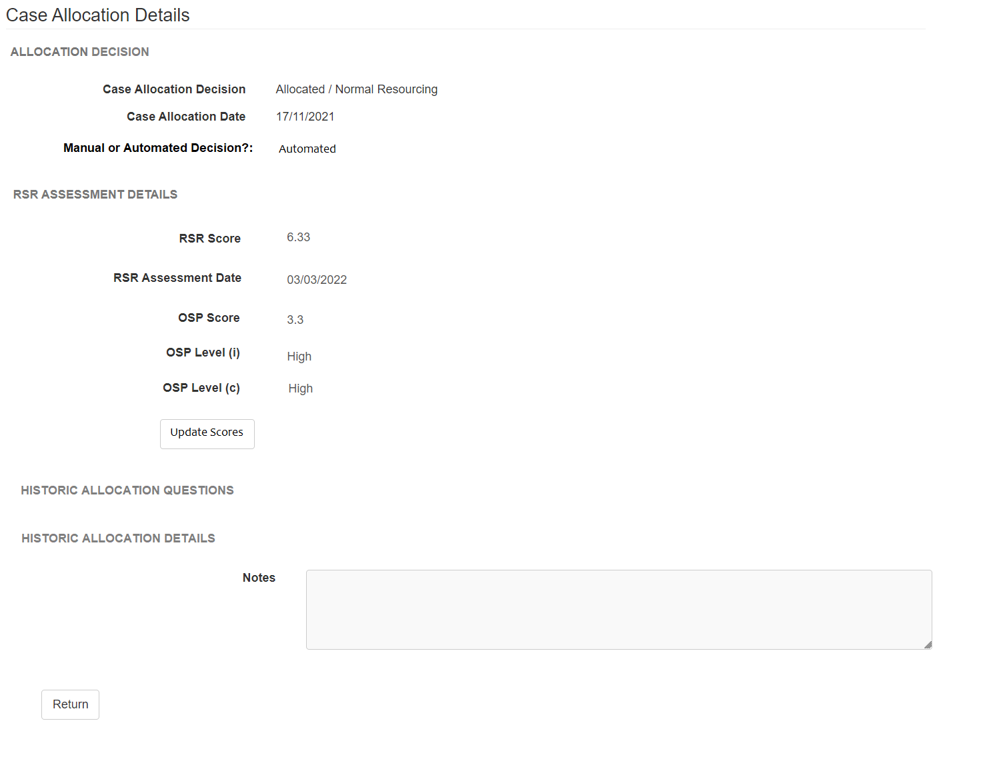

NB: Above diagram is an example only, subject to change

1. *Will OMIC cases and OMIC staff in prisons be adversely affected by these changes?*

No, there will be very little impact to OMIC cases and OMIC staff and the process will continue to work as it does now. The ability to differentiate between levels of resource allocation and handover points is retained through the retention of the CAS decision screen, which the MPC digital function will use to communicate allocation information in the same way as it currently does.

1. *What if a CAS has not been completed on a case?*

Previously, where no CAS has been completed on a case the allocation decision defaults to legacy-NPS allocation criteria for OMiC purposes. The new process will automate the CAS decision, meaning that all cases will have an allocation outcome recorded on the CAS decision screen.

1. *What happens if there is a change to the assessment of a case?*

We recognise that case assessments are fluid and that a multitude of factors may change during the period of a sentence. This can include changes to risk assessments, nationality, MAPPA levels etc.

The new automated CAS decision process draws upon existing data fields, meaning that as a POM/COM records any changes which impact upon these fields the CAS allocation decision will be updated. This up-date does not occur on a real-time basis but will be reflected daily.

As a result, the previous process requiring POM/COMs to update the CAS tool whenever there was a change in circumstance is no longer required.

1. *When are these changes taking place?*

These changes will be implemented with the launch of the next Delius upgrade. This release is anticipated to happen on 2 July 2022.