**PDU Detached Duty Support Pack**

Hammersmith | Fulham | Kensington | Chelsea | Westminster

September 2022

Version 1.0

**Welcome Note**

I would like to take this opportunity to thank you considering taking part in the detached duty / loan arrangements to support our PDU and we want to give you as much information as possible to encourage you to take the exciting opportunity to experience a different working environment in our vibrant capitol city.  As you would imagine, due to our staffing shortages we have had to adapt our service delivery and as a result some expectations will be slightly different to what you may be used to.  We have included links in this document to guidance that will help you adjust to this.  We are a friendly, welcoming and supportive team and we encourage feedback and open communication, please do seek support if there is anything you are unclear about.

Thank you in advance for the invaluable support you can bring and we are excited to welcome you into the team in the very near future.  We know that you will find it a rewarding and enjoyable experience.

**Rekha Brigue**

Head of Service - HFKCW

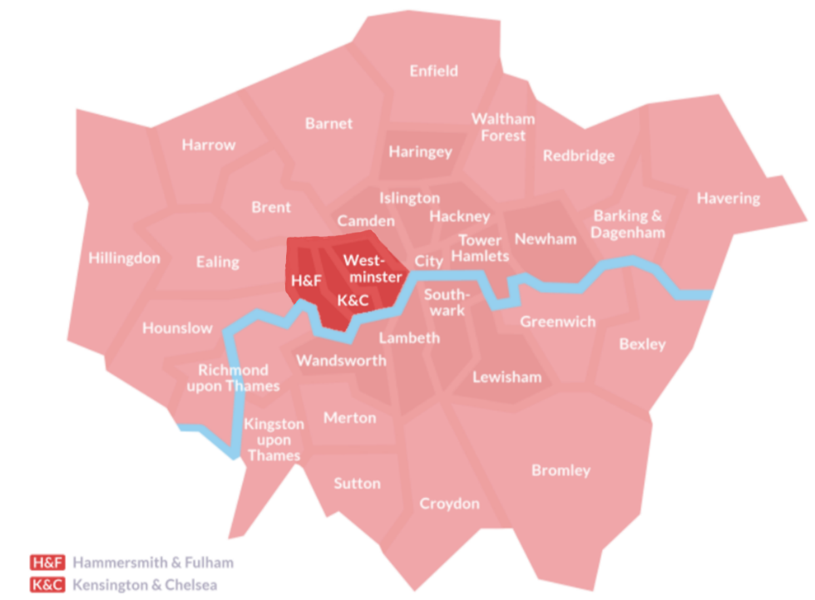

**Office Location**

The office address is [191a Askew Road, London, W12 9AX](https://www.google.com/maps/place/Askew+Rd,+London+W12+9AX/@51.4997298,-0.2441084,15.25z/data=!4m5!3m4!1s0x48760e33d4cddd23:0x3e82029abcc6e215!8m2!3d51.5016581!4d-0.2407245).

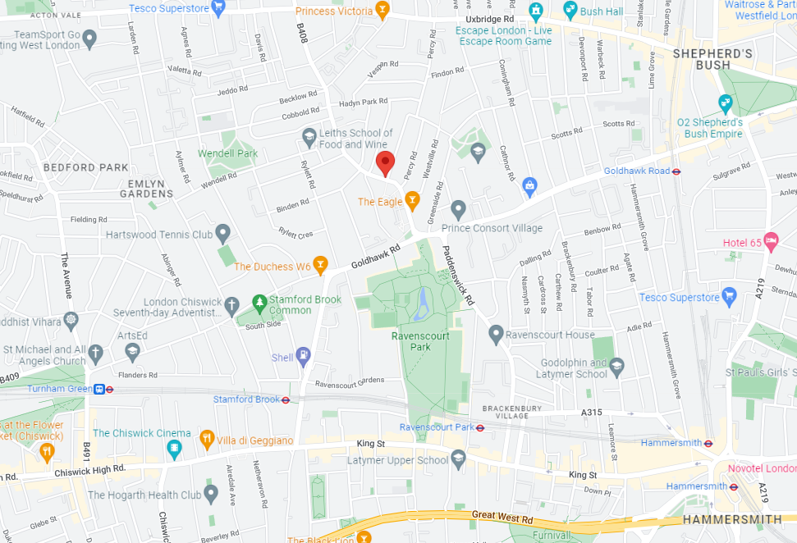

**London Underground**

Tube stations within walking distance are Stamford Brook (District line); Ravenscourt Park (District line); Goldhawk Road (Circle, Hammersmith and City lines).

Shepherds Bush (overground and Southern Rail) station and Hammersmith station (Circle, Hammersmith and City, Piccadilly and District lines) are also nearby but is a bus journey from there to the office.

**Buses**

From Hammersmith you can take the 218 or 306, or from Shepherd’s Bush you can take the 237, 207, 94 or 260.

**Travel and Accommodation**

All travel and accommodation is booked via the DigiTS portal at this link:

[Home - DigiTS (crowncommercial.gov.uk)](https://travel.crowncommercial.gov.uk/).

**London Underground Map** – Includes guidance on step-free access



**Citymapper** – App for your phone that generates step-by-step route plans including all forms of transport.

**[](https://citymapper.com/?lang=en)**

Some suggestions of nearby hotels:

**Premier Inn London Hammersmith (Ravenscourt Park)**

Hammersmith, London, W6 9LU **Distance:**0.6 miles

**Holiday Inn Express London Hammersmith**

Hammersmith, London, W6 0QU **Distance:**0.7 miles

**Ibis Hotel Shepherds Bush**

Shepherds Bush, London, W14 0DJ **Distance:**0.9 miles

**Novotel London West Hammersmith**

1 Shortlands, London, W6 8DR **Distance:**1.1 miles

**Hilton London Kensington**

179-199 Holland Park Avenue, London, W11 4UL **Distance:**1.2 miles

**Travelodge London Acton**

Victoria Road, London, W3 6UU **Distance:**1.6 miles

**Who’s Who?**

**Management Team**

|  |  |
| --- | --- |
| **Head of Service** | Rekha Brigue |
| **Deputy Head of Service** | Sarah Port  Hardeep Lalli (Interim) |
| **Senior Probation Officers** | Martin Hessic  Lawrence Francis  Hannah Woodward  Paul Allott  Taj Gill (Court) |
| **Business Manager** | James Andrew (Interim) |
| **Senior Admin Officers** | Priscilla Amponsah  Vivian Akinbanjo  Dean Chambers |
| **Diary Manager** | Shaun Sehmi |

**PDU Organogram**

**Reporting Schemes**

The PDU is currently operating two reporting schemes to supervise unallocated cases, one providing face-to-face appointments and the other by telephone contact. Face-to-face appointments are currently conducted by NQO staff, and telephone reporting undertaken by PSOs. Initial appointments for unallocated cases following sentencing at court are undertaken by Practitioners on rotation for Allocations Duty. Cases are assigned to one of the two reporting schemes depending on their tier and safeguarding needs.

**Detached Duty or Loan – which arrangements apply to me?**

This will depend on your own individual circumstances based on your contractual terms and conditions of service. The following information is intended to help explain this further.

**Detached Duty (DD)**

This scheme will apply to probation staff (including those working in HQ or HMPPS) employed on Probation Service terms and conditions (T&C’s) of service.

**How the National Detached Duty Scheme will operate**

As detailed in NTS 32/2019, a non-consolidated but pensionable Detached Duty Scheme lump sum payment will be paid to staff **that volunteer**, following completion of the agreed DD deployment as below:

4 weeks continuous      = £500

8 weeks continuous      = £1,200

12 weeks continuous    = £2,000

Staff that agree to a period of 12 weeks DD are permitted to take up to two week’s paid annual leave and extend their deployment accordingly. Thus the 12-week DD can be completed over a 14-week cycle.

Pro rata non-consolidated Detached Duty Scheme lump sum payments are not made for any partially completed periods (e.g. if staff completed only 10 weeks Detached Duty – they would receive the £1,200 Detached Duty Scheme lump sum).

Detached Duty will normally be interrupted by any period of absence that exceeds 5 working days. When such occurs the staff member should report back to their substantive place of work.  Divisional Directors for the receiving site can approve exceptions and permit the period of detached duty to continue or be extended.  In such cases Detached Duty Scheme lump sum payments will still be made, based on the actual weeks of DD that are completed.

All Detached Duty Scheme lump sum payments reflect full time, 37 hours per week working.  Pro-rata amounts will be paid for part time staff undertaking detached duty.

**Loan**

Alternatively, for those staff who are employed on different terms and conditions of service, e.g. HMPPS or MOJ T&C’s, the aforementioned Detached Duty Scheme will not apply. Instead, subject to manager approval, a loan agreement can be offered to staff who volunteer for 4, 8 or 12 week periods of deployment. In these cases, a comparable lump sum payment will be payable via the Reward and Recognition Scheme (subject to an individual’s annual limit), on completion of their agreed loan period.

**Examples**

Staff member currently working in a HQ or HMPPS role but is employed on probation T&C’s – the Detached Duty Scheme will apply.

Staff member currently working in HQ or HMPPS role but is employed on HMPPS or MOJ T&C’s – a Loan Agreement will apply.